**Exposing RESTful Services using APEX and ORDS**

Join Doug Gault from the APEX Development Team as he builds, tests and protects a set of RESTFUL services using a combination of the APEX RESTful Services Console and ORDS APIs. We’ll look at protecting REST services using BASIC and OAUTH2 Authentication and review two example PL/SQL code blocks that consumes the protected service.

Session Chat: <http://bit.ly/apex_office_hours_chat_20190516>   
Session Slides: [https://www.slideshare.net/DougGault/oracle-office-hours-exposing-rest-services- with-apex-and-ords](https://www.slideshare.net/DougGault/oracle-office-hours-exposing-rest-services-with-apex-and-ords)   
Recordings in the past to view

<https://apexapps.oracle.com/pls/apex/f?p=20051:2>::::::

Video Highlights:

Join Doug Gault from the APEX Development Team as he builds, tests and protects a set of RESTFUL services using a combination of the APEX RESTful Services Console and ORDS APIs. We’ll look at protecting rest services using OAUTH2 and an review an example PL/SQL code block that consumes the protected service.  
  
Slides: https://www.slideshare.net/DougGault/oracle-office-hours-exposing-rest-services-with-apex-and-ords  
  
Frist 3 Minutes - Introduction  
03:06 - Brief Introduction to REST  
05:18 - Brief History of REST in APEX and ORDS  
08:55 - High Level Overview of the ORDS and its APIs  
16:15 - ORDS Enabling an Oracle Schema   
19:54 - ORDS AutoREST Description  
22:45 - ORDS AutoREST Demonstration   
29:03 - Manual REST Service Creation Description  
32:32 - Manual REST Services Demonstration   
44:20 - Securing ORDS REST Services  
45:19 - Common types of Authentication   
46:26 - ORDS Basic Authorization Description   
49:39 - ORDS REST Basic Authorization Demonstration  
53:00 - ORDS OAUTH2 Description   
56:30 - ORDS OAUTH2 Demonstration   
58:30 - Consuming ORDS REST from PL/SQL  
60:00 - Q&A

https://www.youtube.com/watch?v=DJL2NdYQ234&feature=youtu.be

Basic communications.

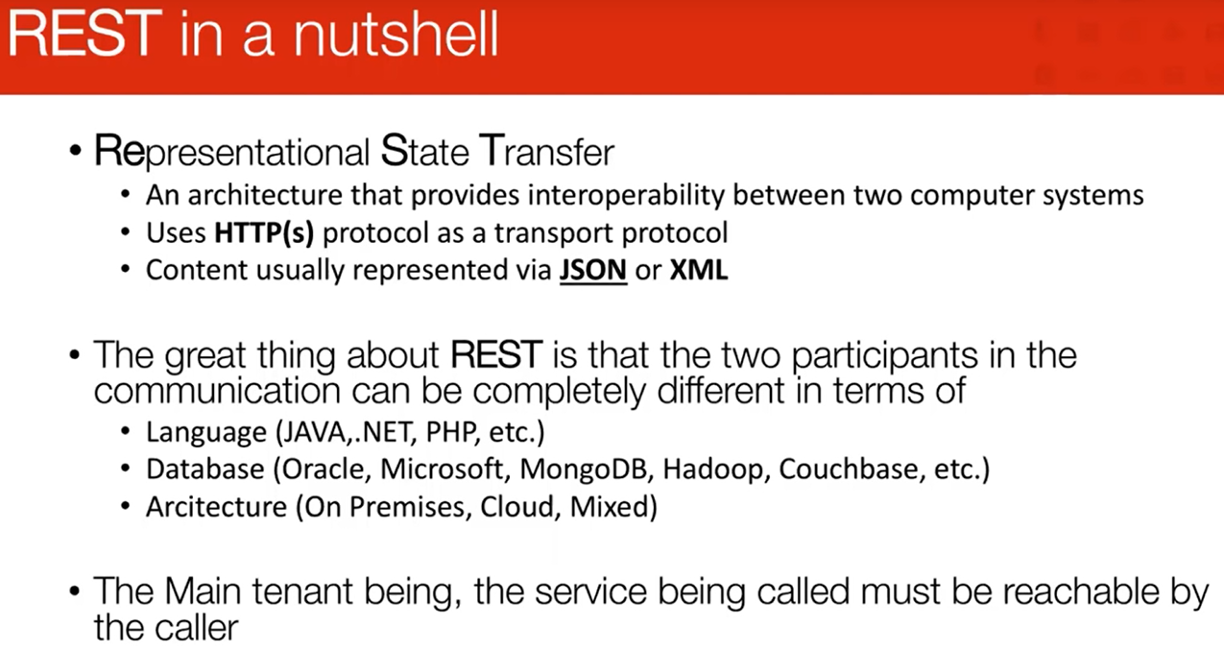

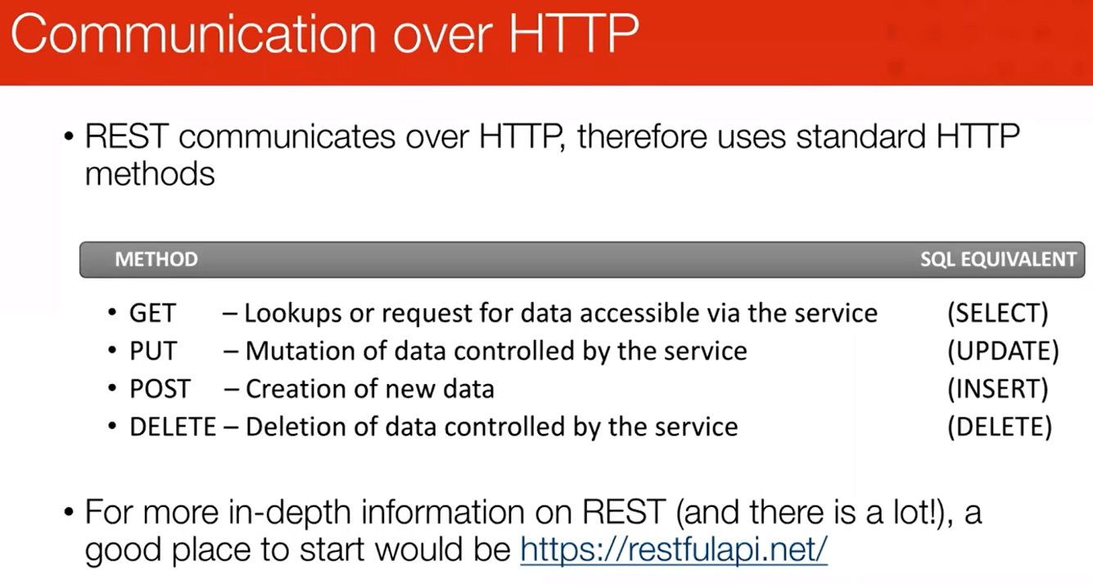

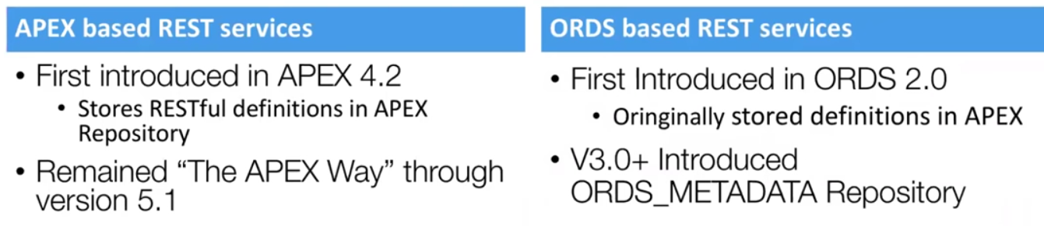

Because people want to split rest services away from dependencies on apex install, ords grew.

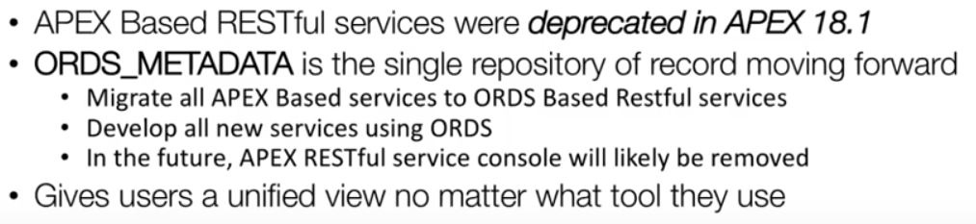

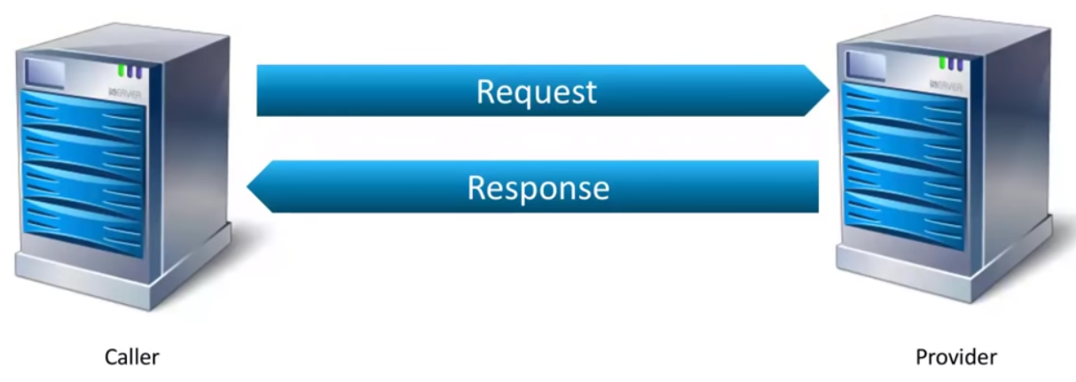

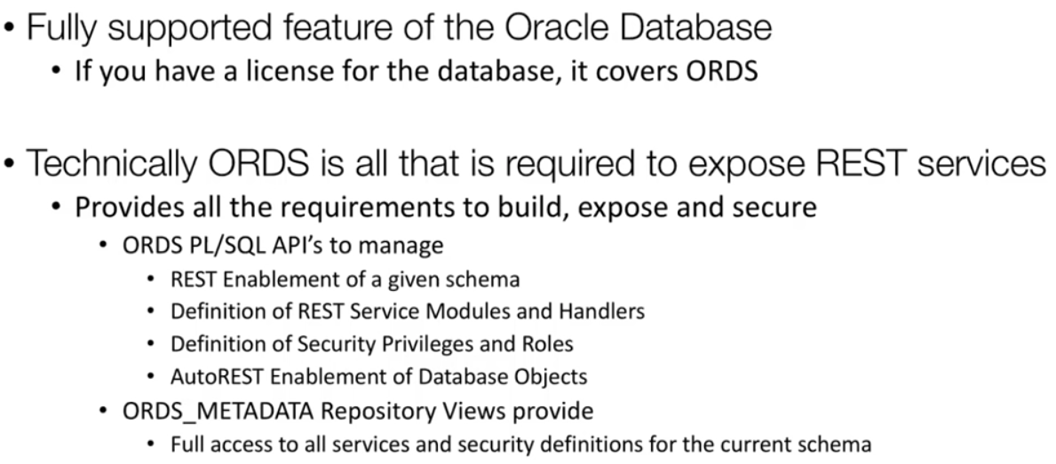

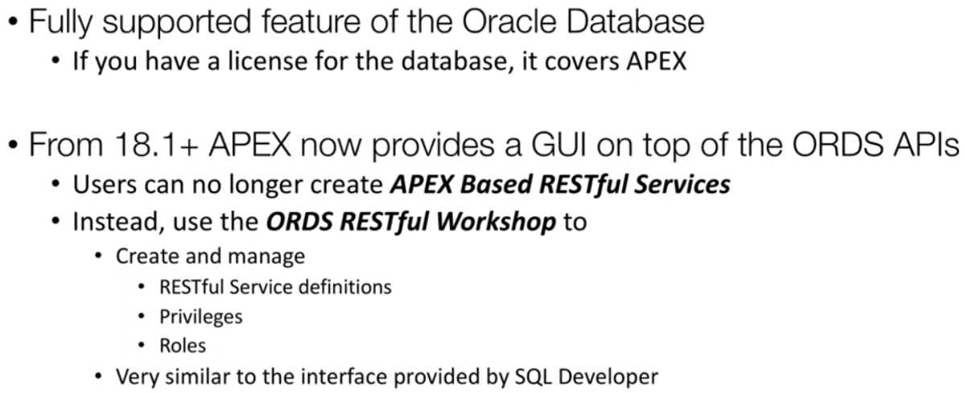



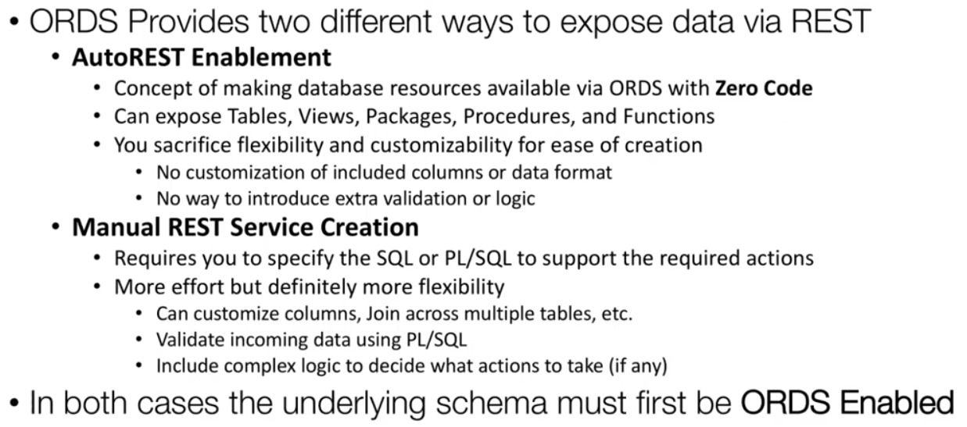

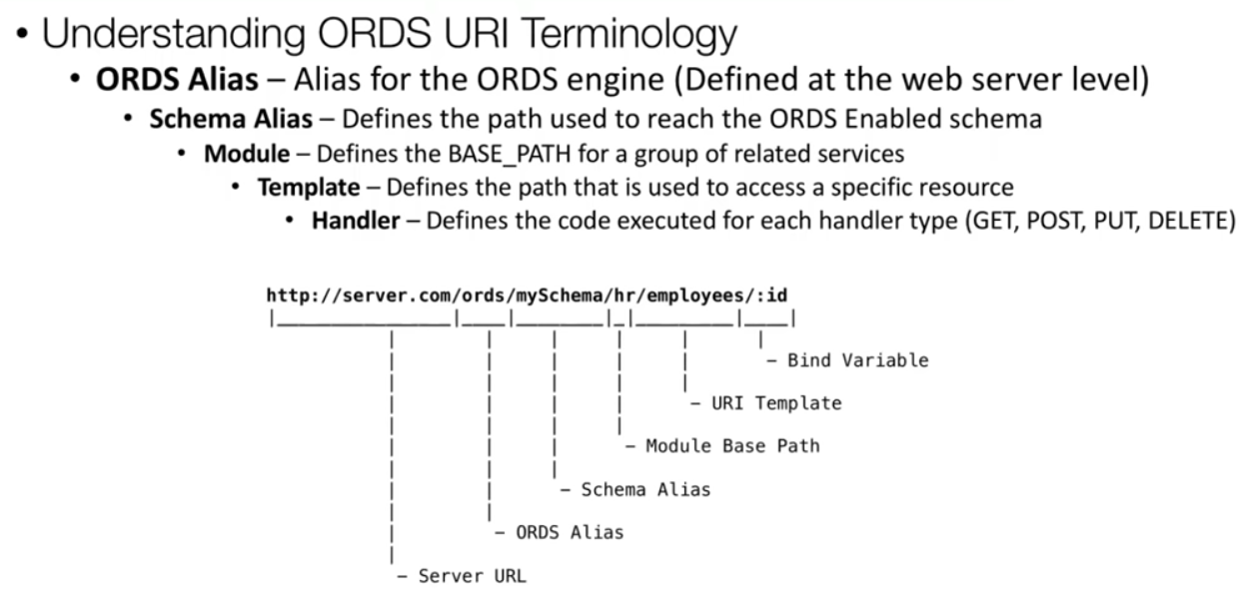

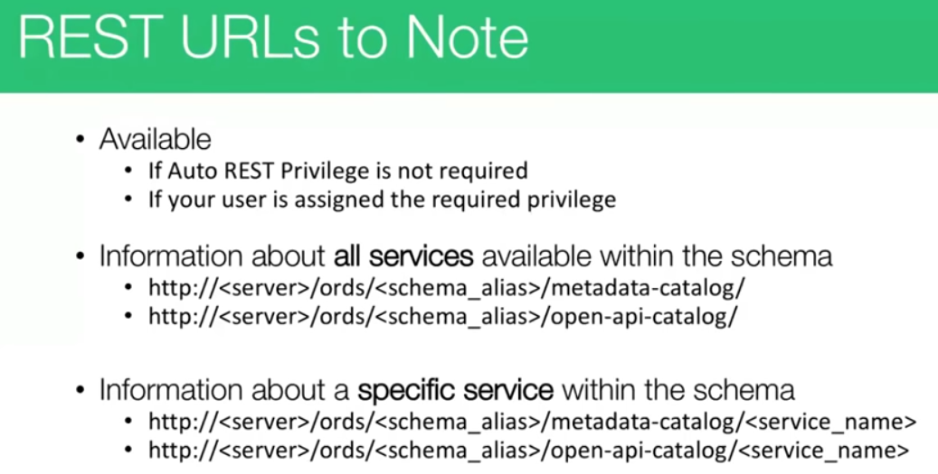

What is available in your schema exposed at rest. Preferred is

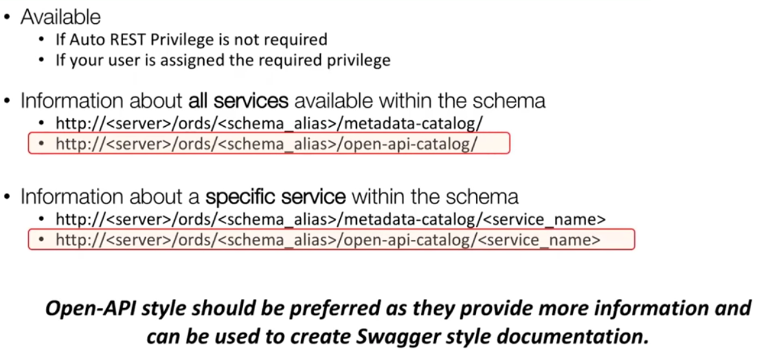

Thru swagger.

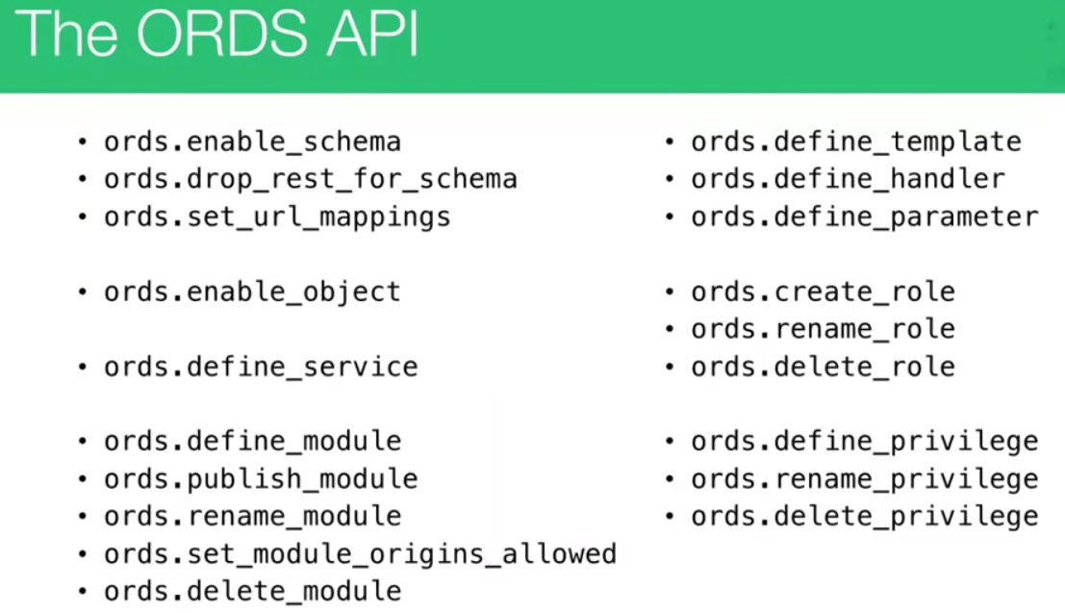

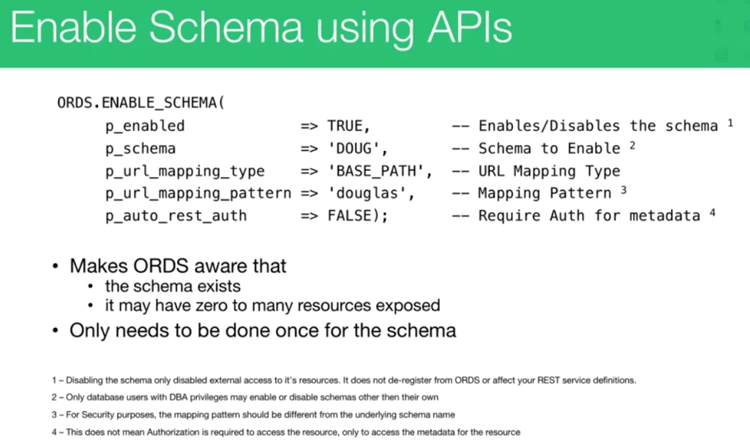

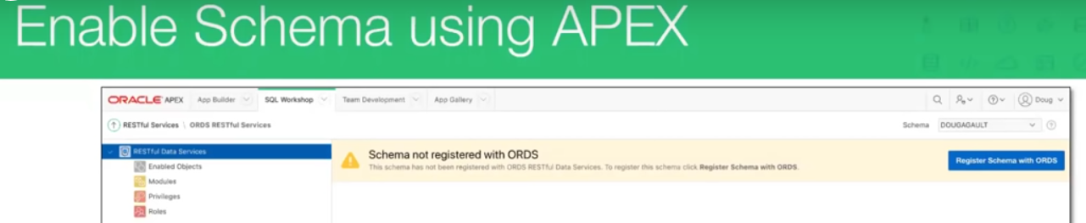

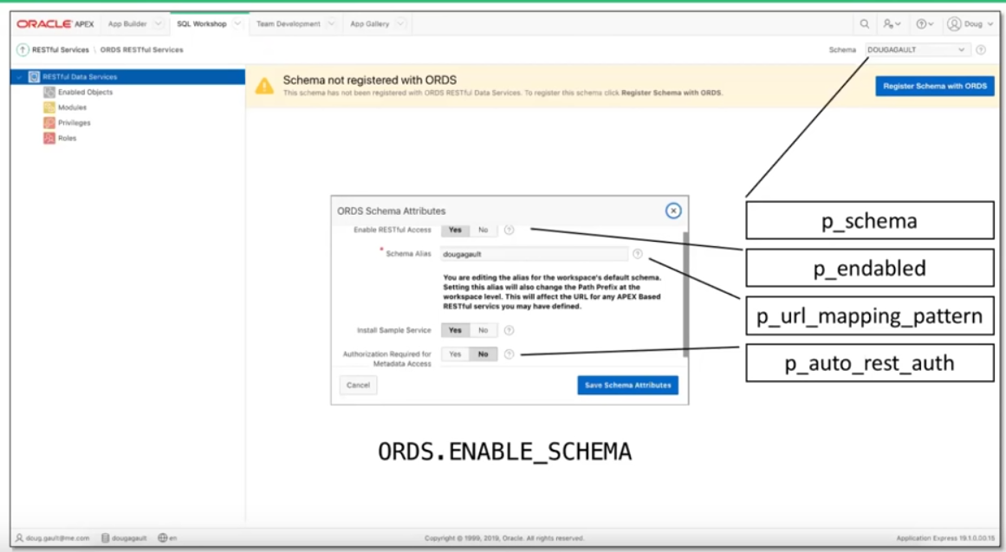

Sql workshop, rest services, select ord based resful services.

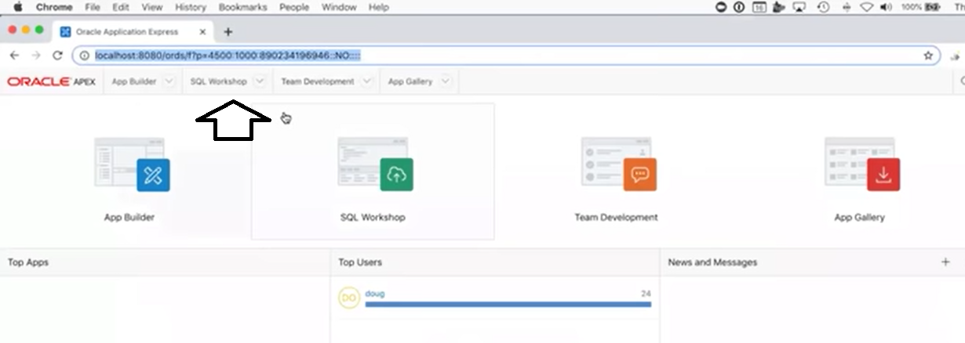

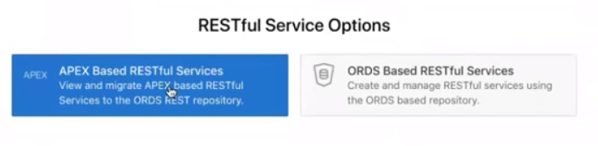

Selec ORDS !!

If schema is not registered with ords you will see this.

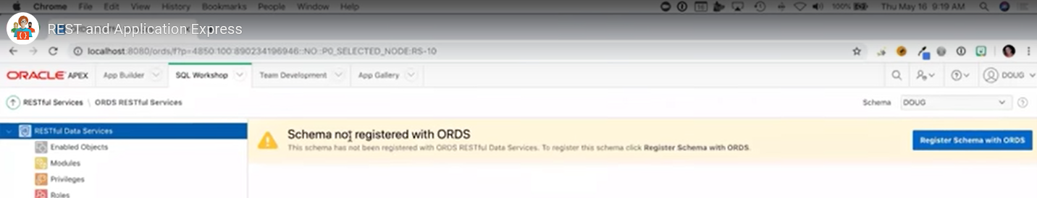

Select register schema

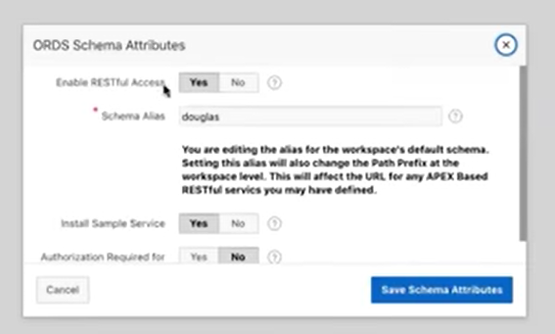

Console shows below:

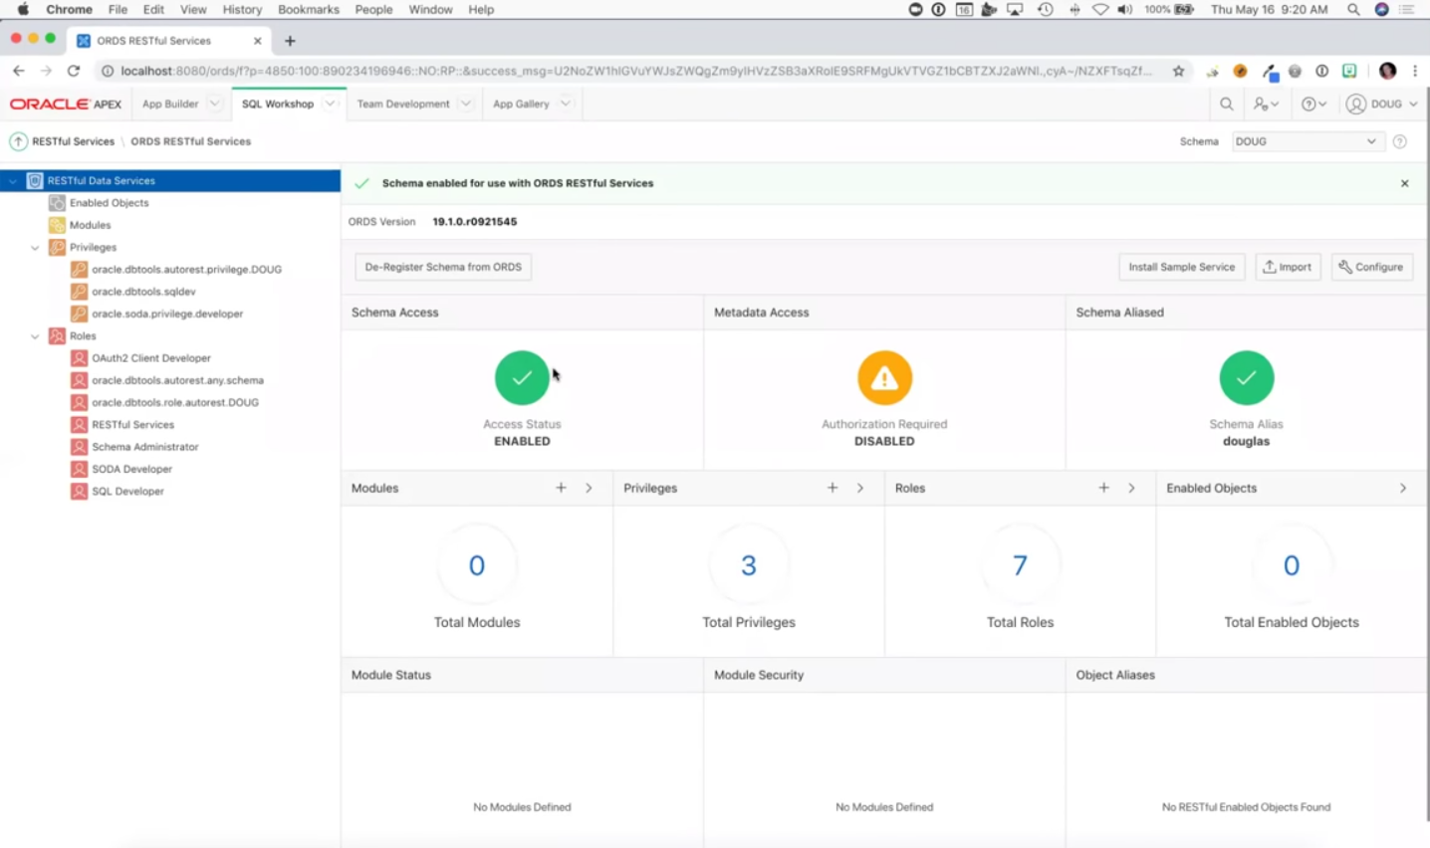

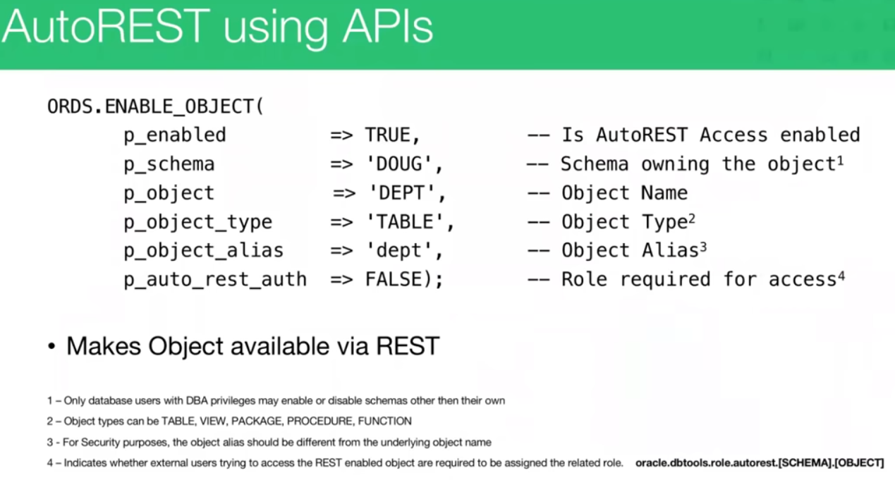

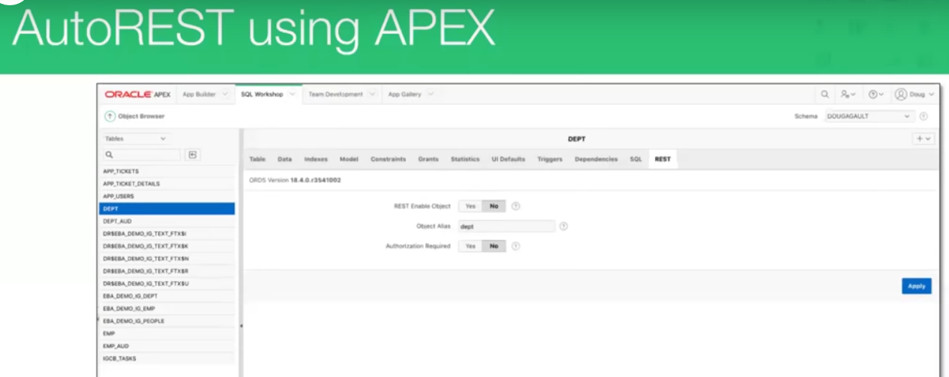in 19

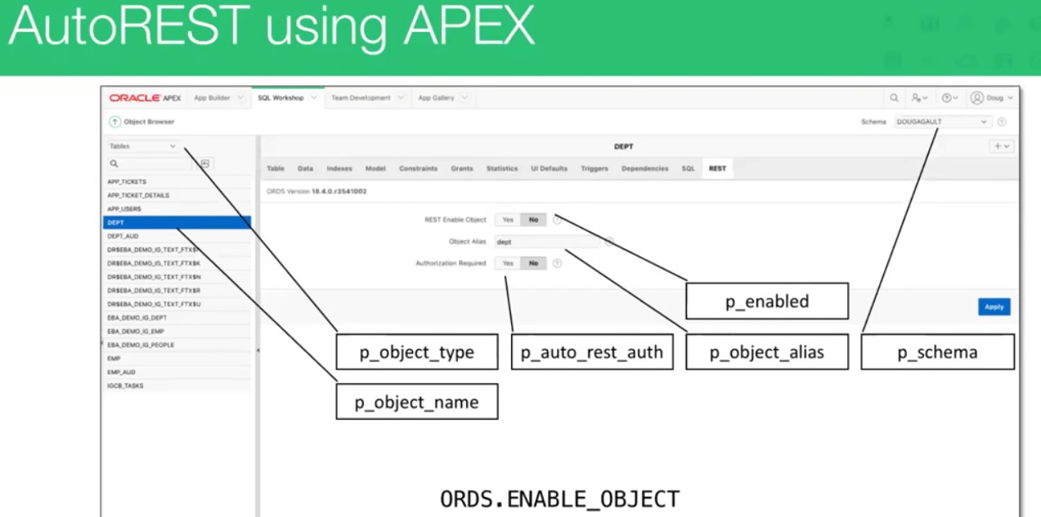

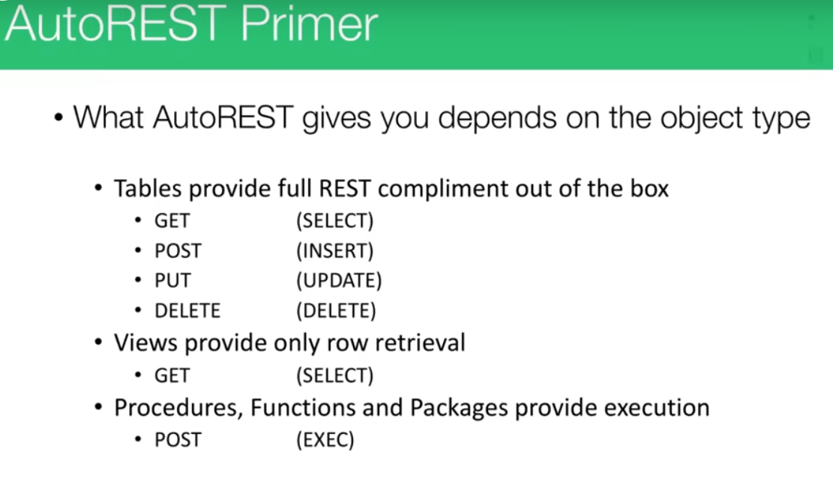

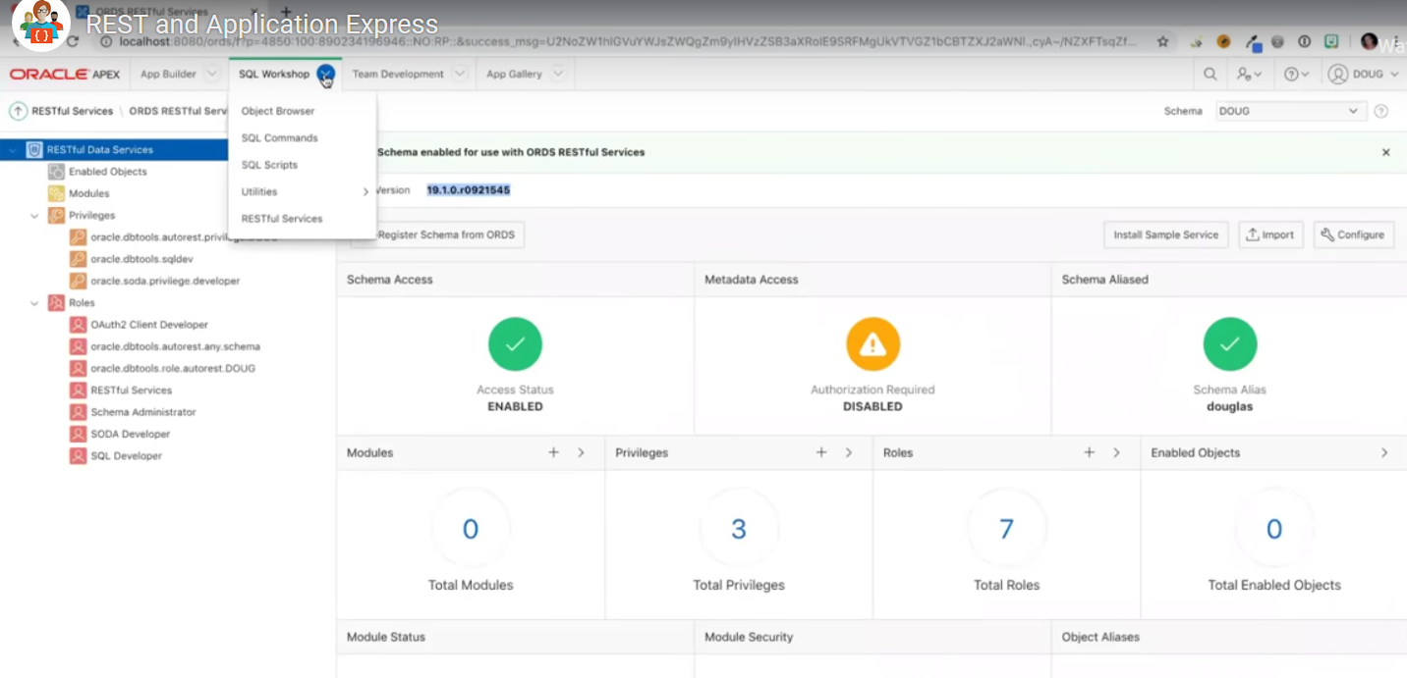

Autorest Demo follows

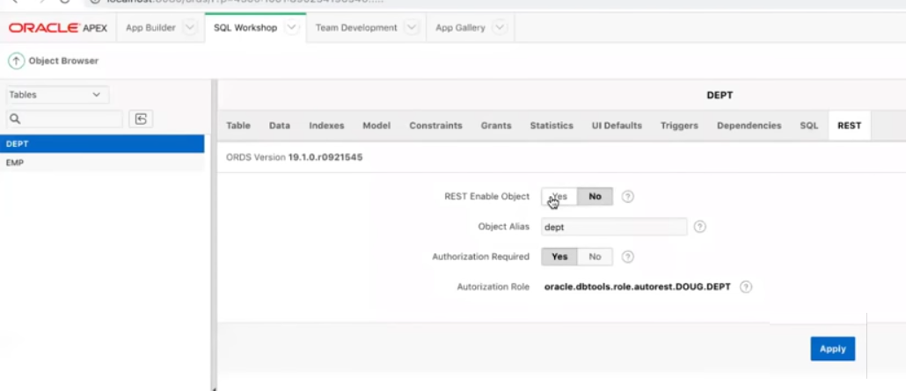

Once you hit apply, it gives you the url you need

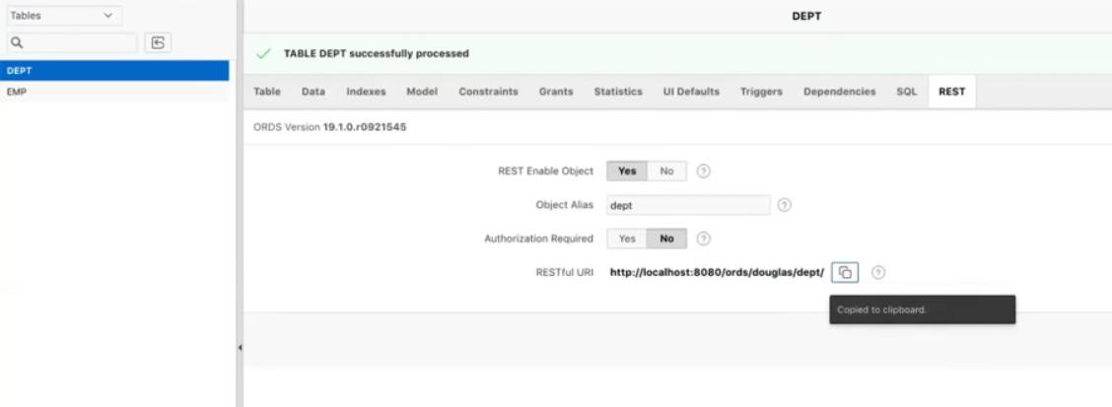

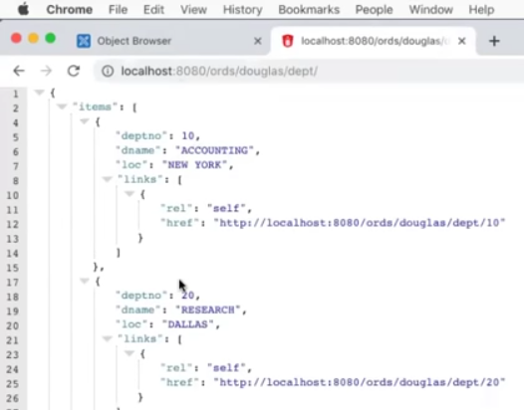

Lets use postman to test rest api’s for dept table

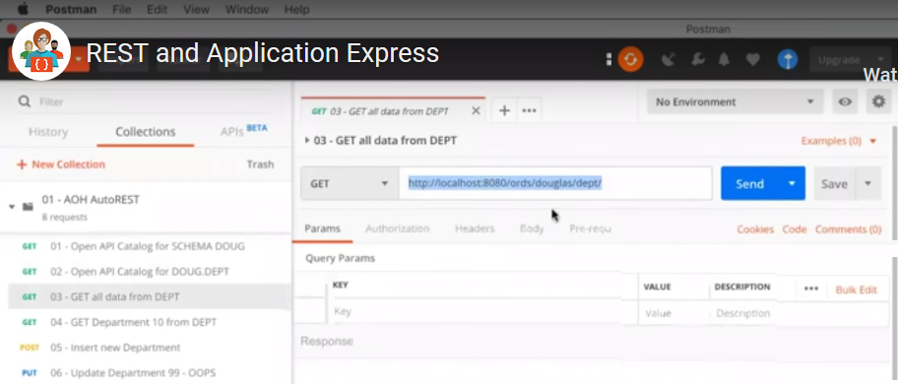

If I send a parameter, say “10” , I get it filtered.

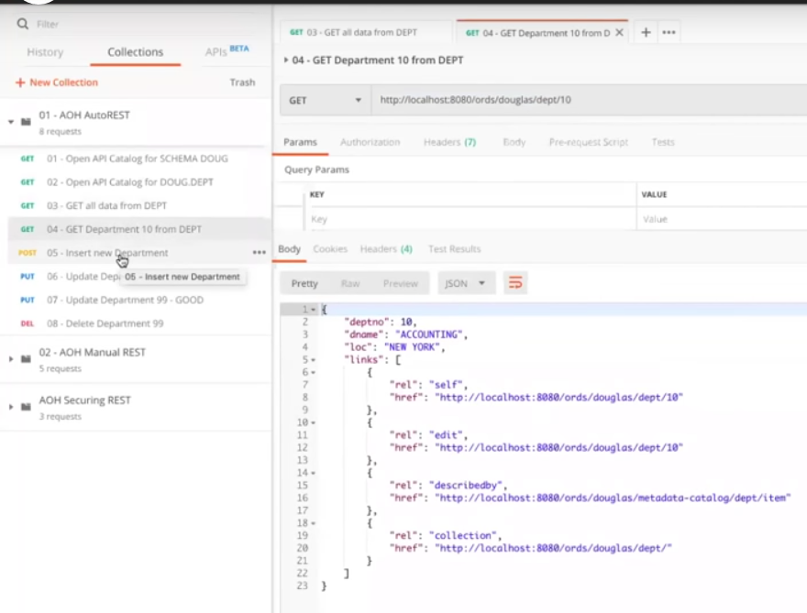

For inserts use this.

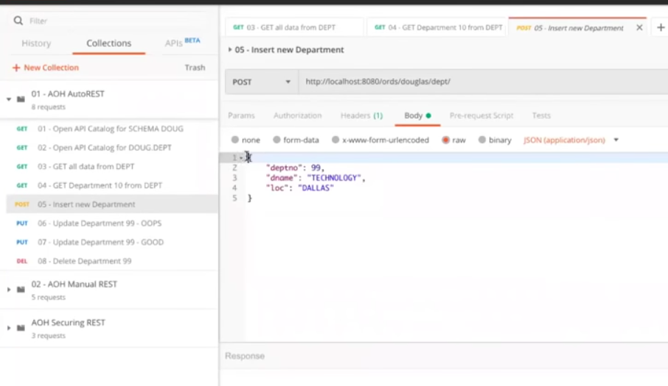

Send the data json in the body of the call, based on column names of the table

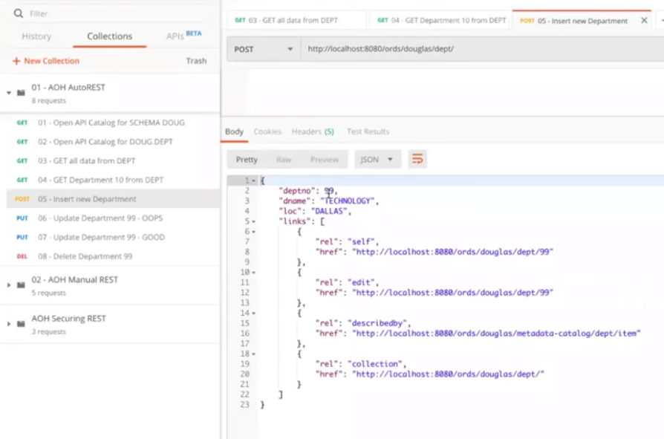

Update uses put api

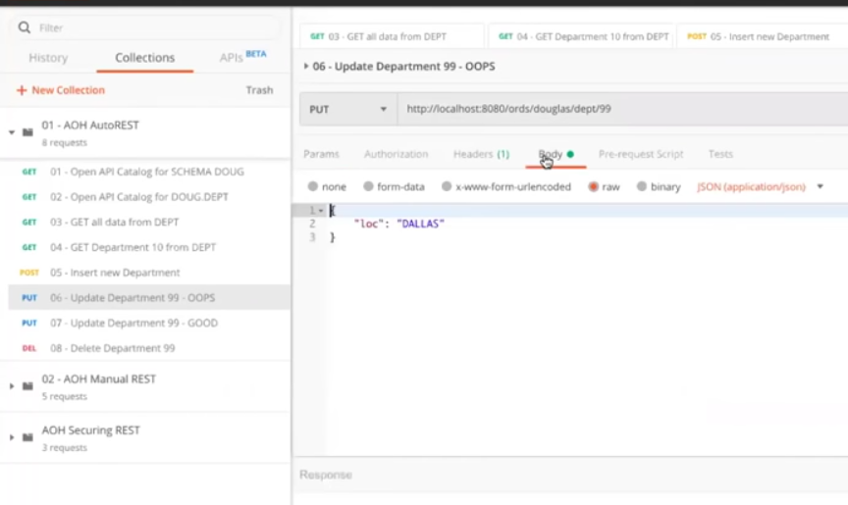

When you update using rest api’s, you have to pass entire record

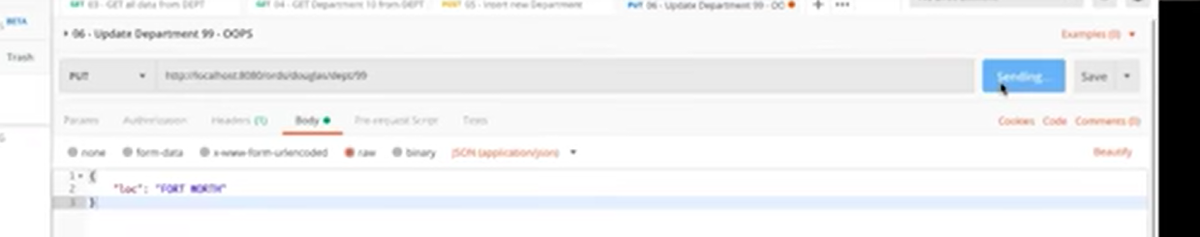

When we update using the ords apis , we have to provide all the values including the things we have not changed.

We have to push back the entire record. So we have to push it all back.

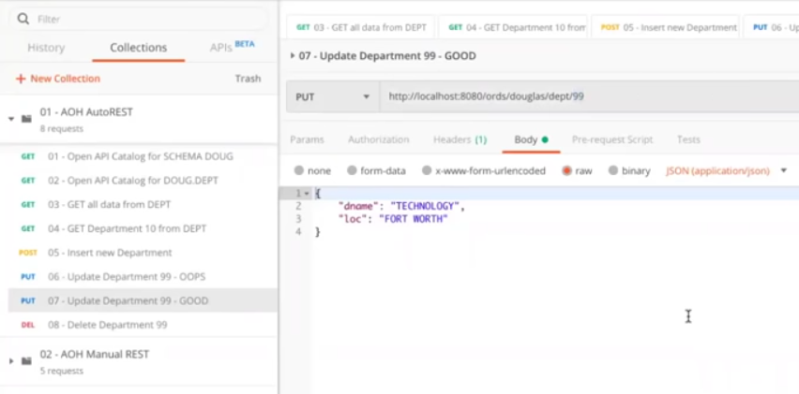

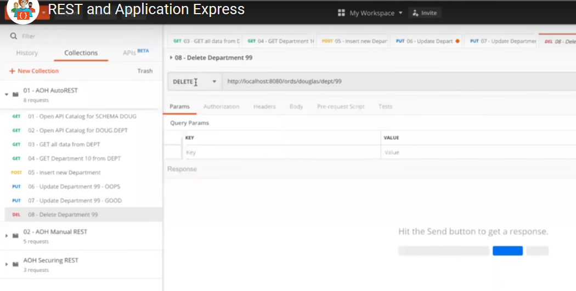

Puts will force a update if the pk is not there.

+++++++++++++++++++++++++++++++++++++++++++++++++++++++++++++++++++++++++

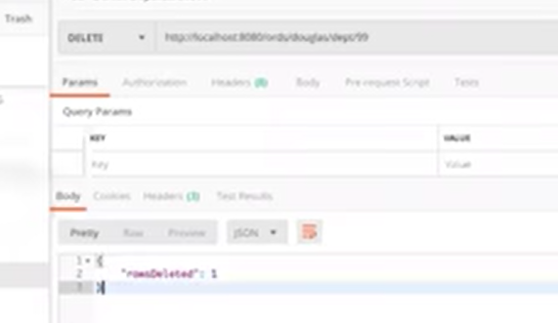

If I update a record that doesn’t exist, but it will create it for you.



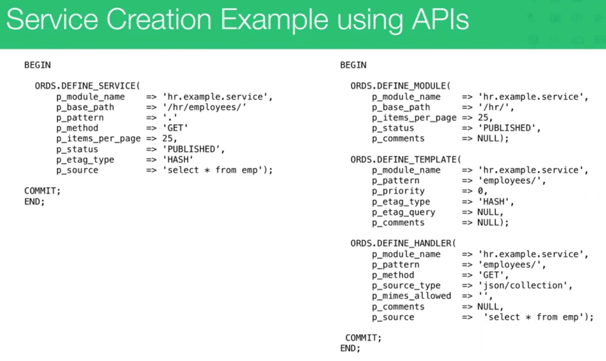

Here are two examples, its best to control everyting by not using define_service

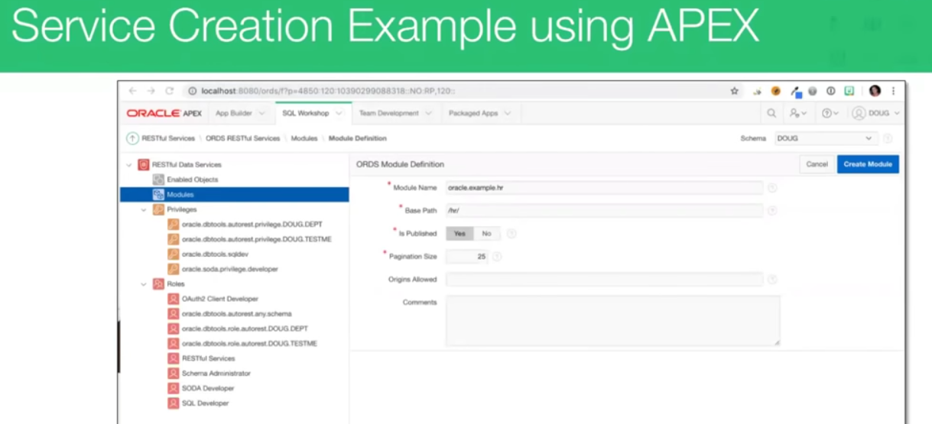

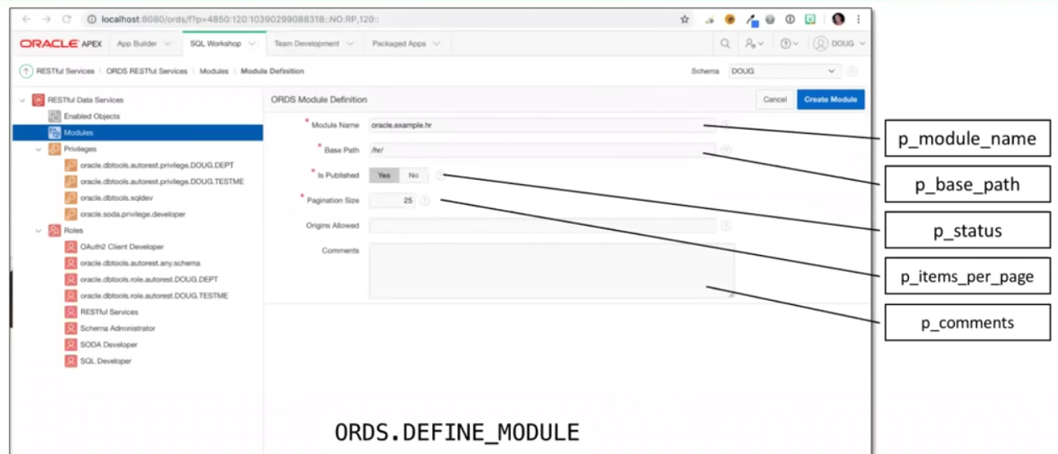

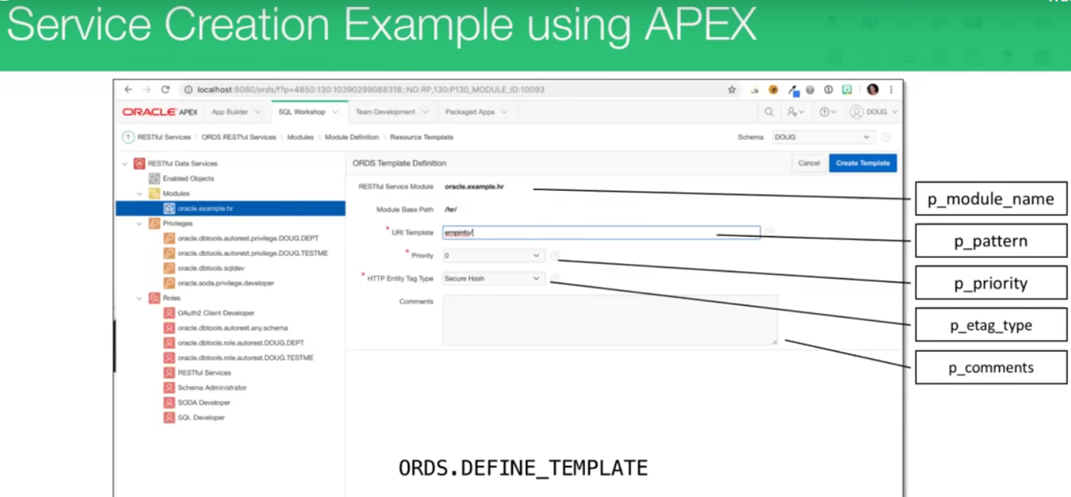

Handlers follow:

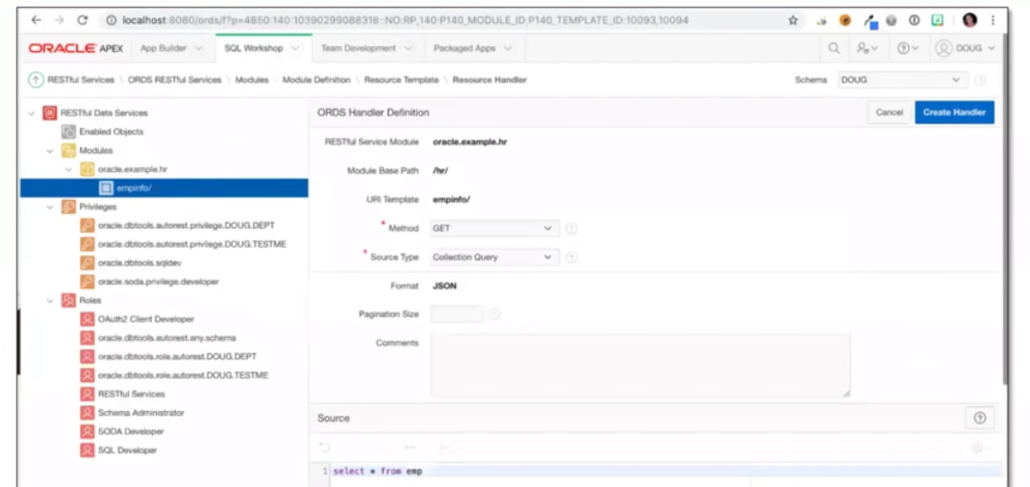

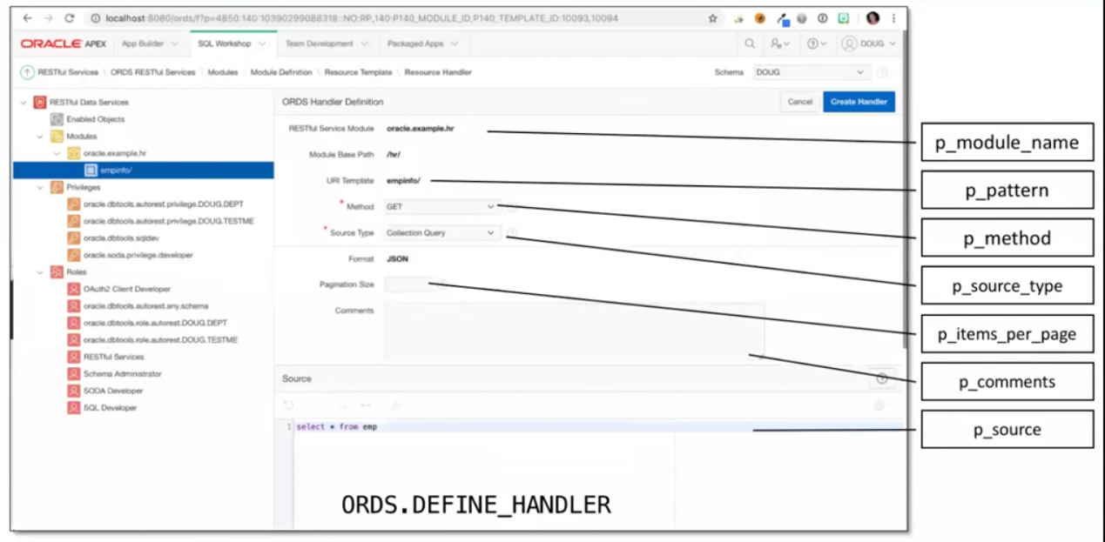

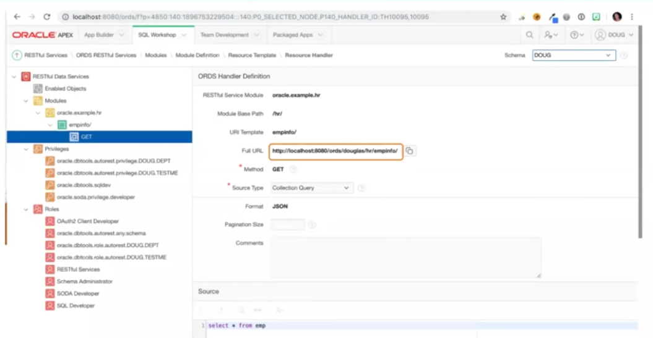

See your url, new handler for each one.

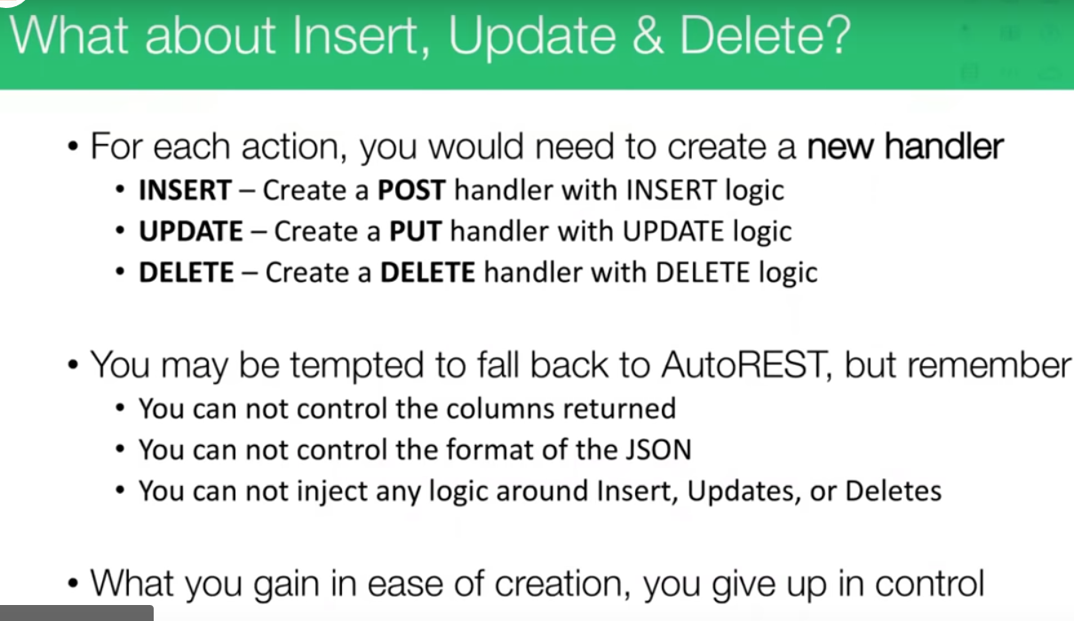

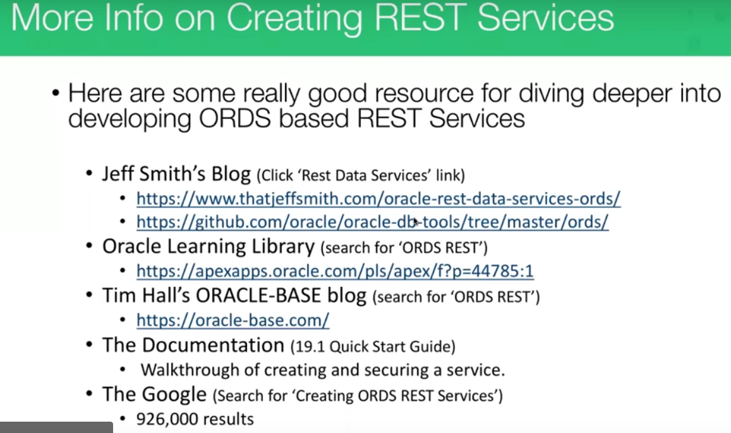

<http://www.thatjeffsmith.com/oracle-rest-data-services-ords/>

<https://github.com/oracle/oracle-db-tools/tree/master/ords>

<https://apexapps.oracle.com/pls/apex/f?p=44785:1>

<https://apexapps.oracle.com/pls/apex/f?p=44785:49:107827512378523::NO:RP>::

<https://apexapps.oracle.com/pls/apex/f?p=44785:50:107827512378523:::50:P50_COURSE_ID,P50_EVENT_ID:288,6049>

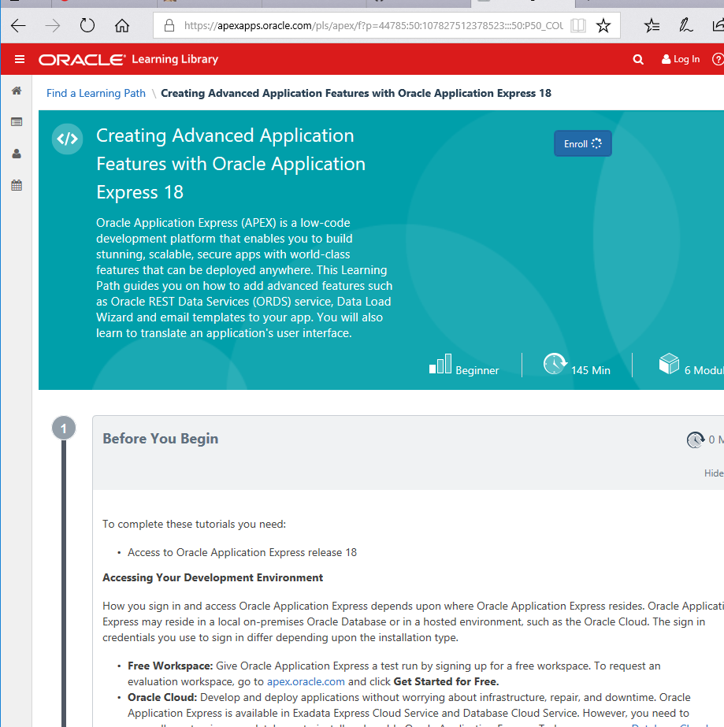

If we import HR modules:

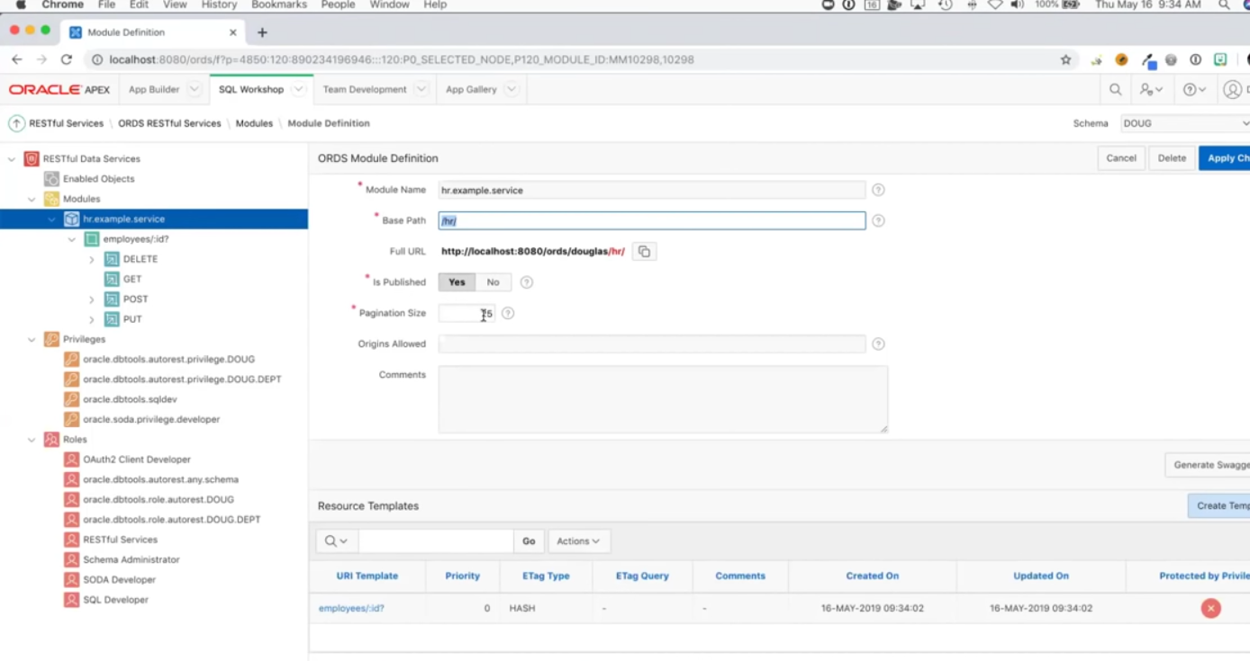 :Var? , ? , makes it optional

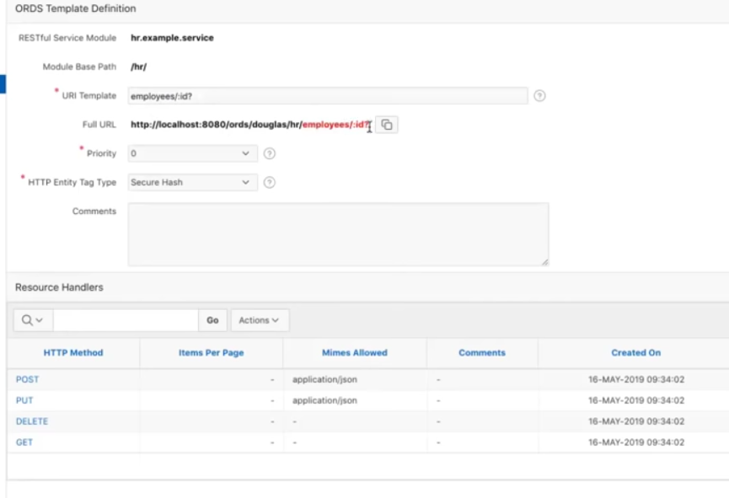

Lets look at get first.

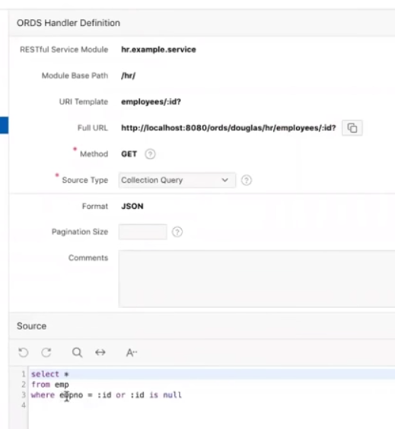

---------------- insert ------------post--

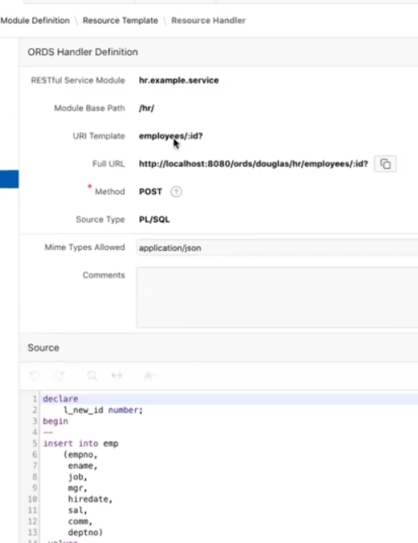

Bind vars in json

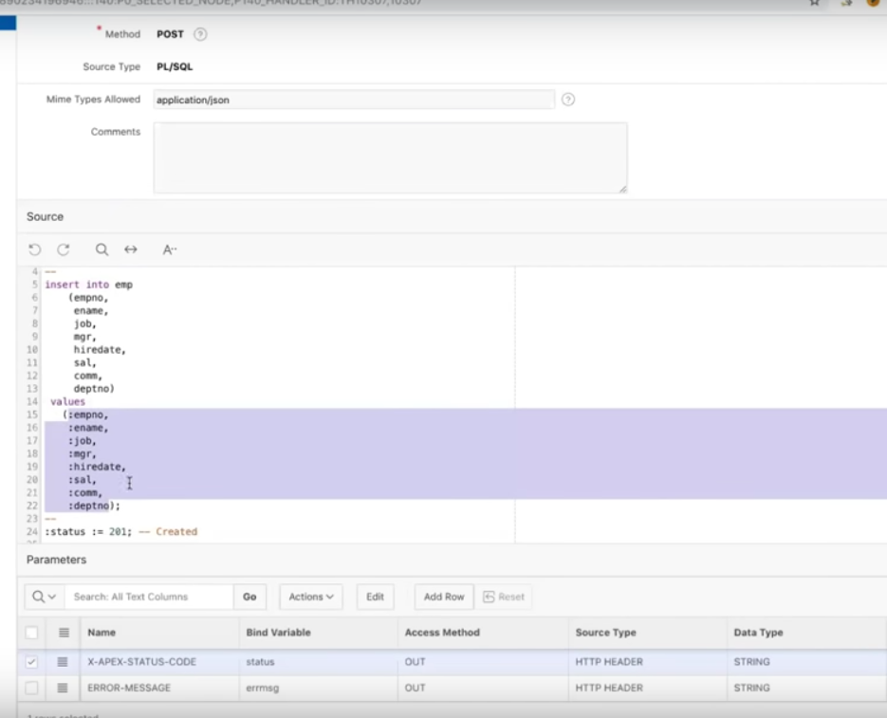

For each element in json build out bind values

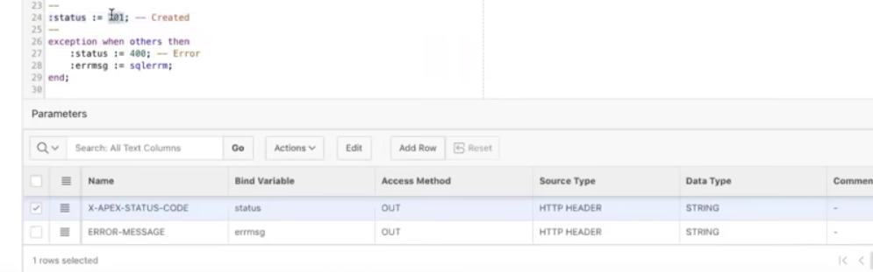

Muse use to pass via ords. Passed back in the header.

========update =============

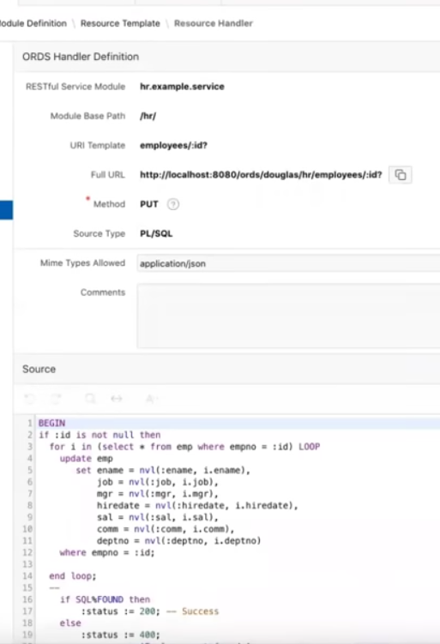

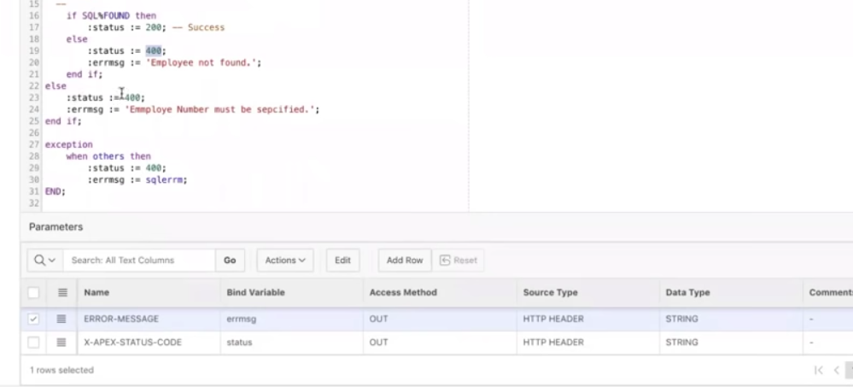

======== delete ==============

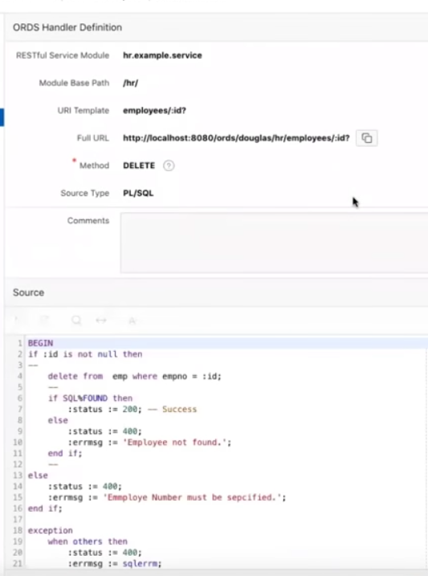

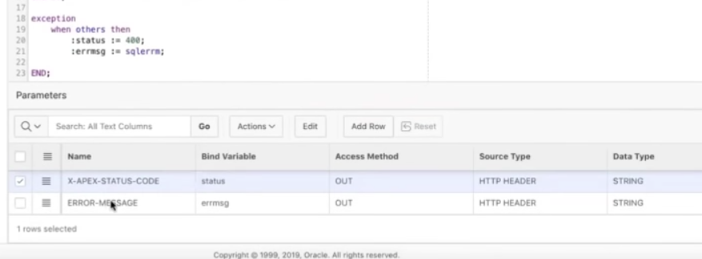

Lets go to postman test this out.

Securing rest services.

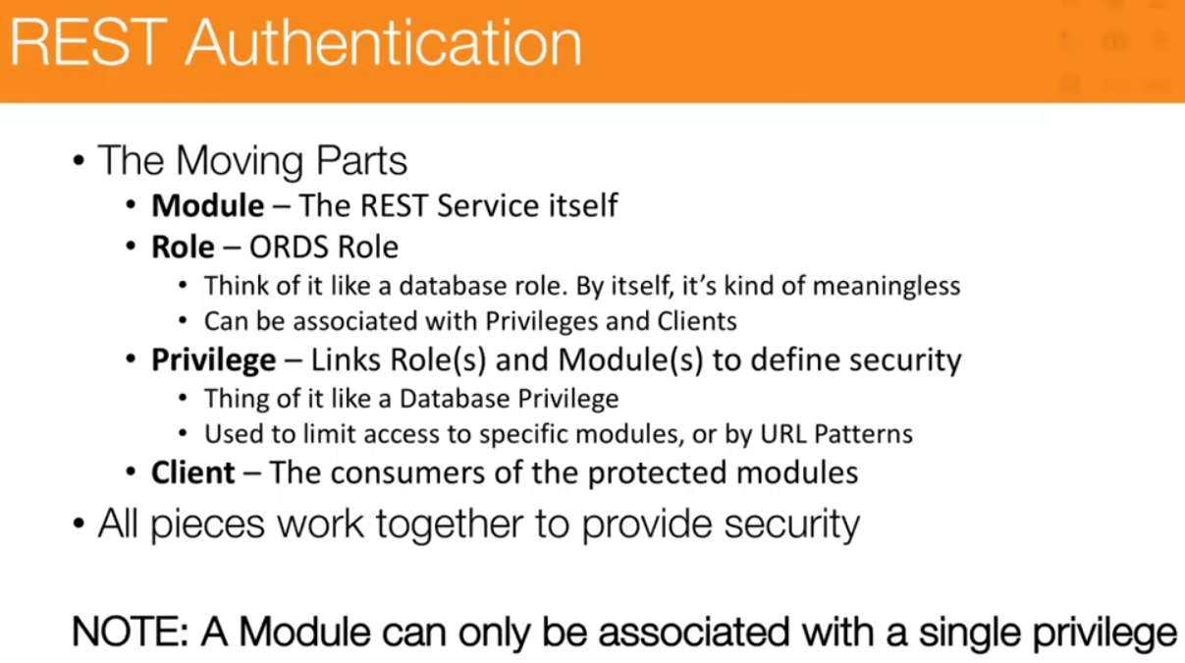

Module assigned to a single privilege only.,

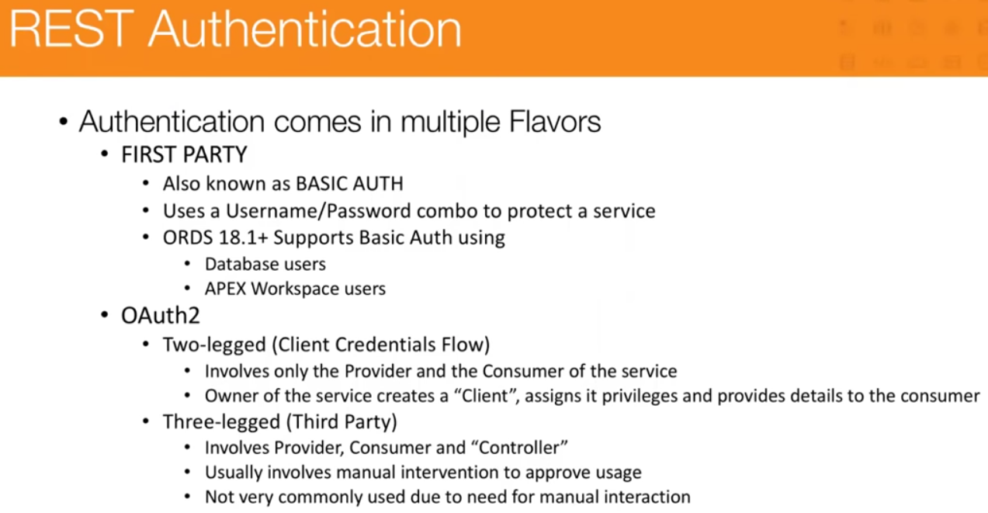

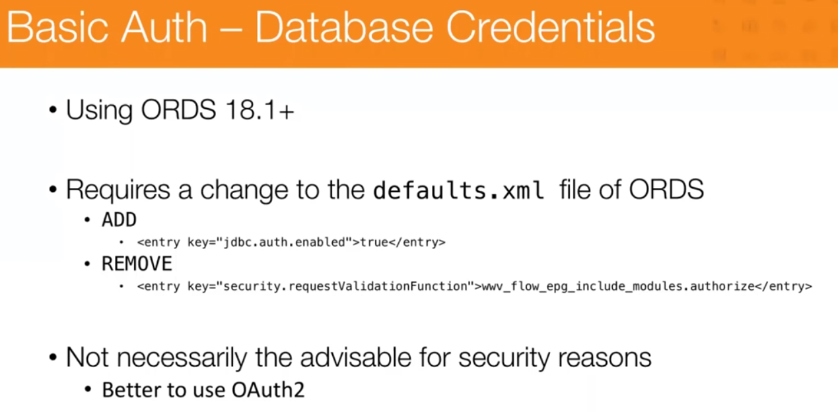

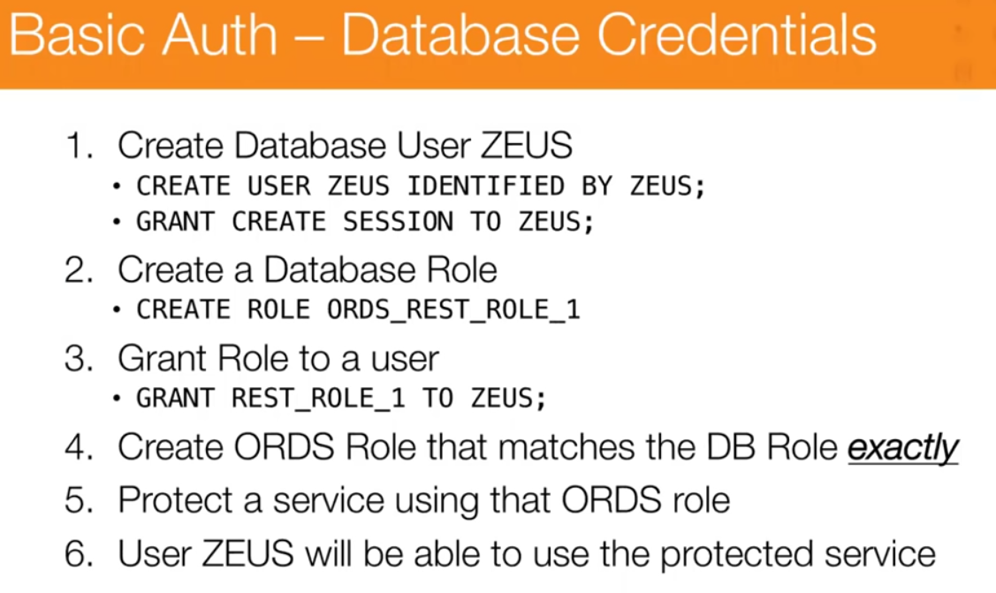

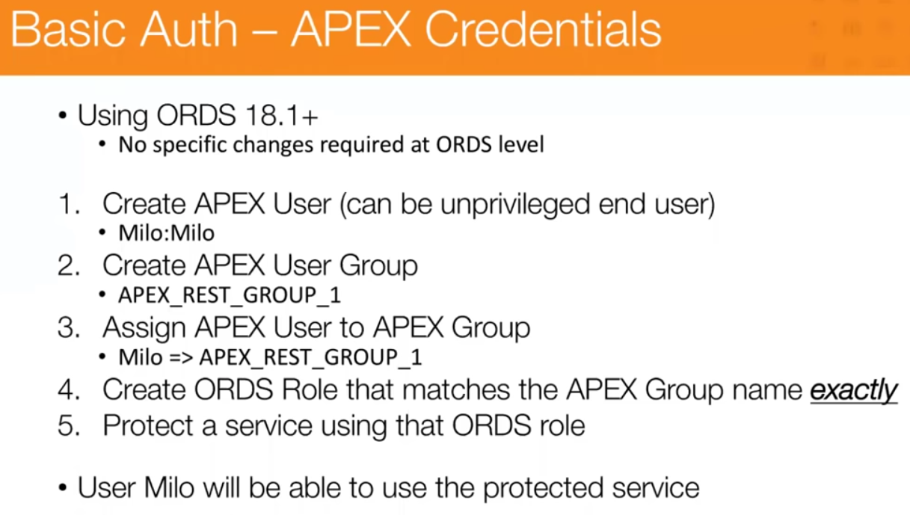

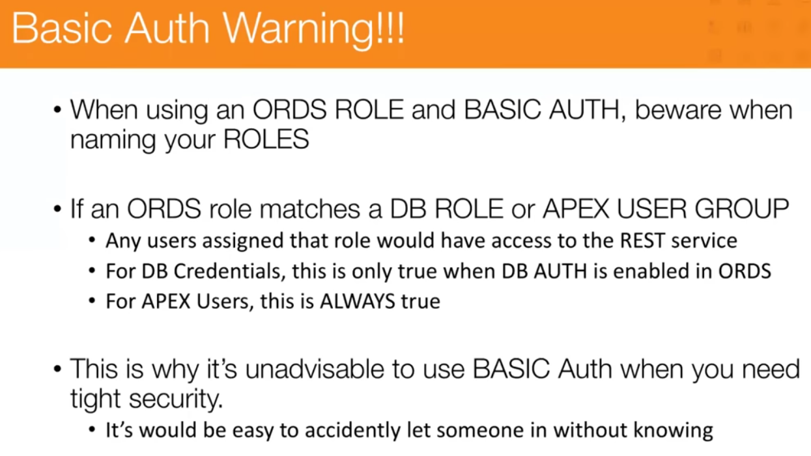

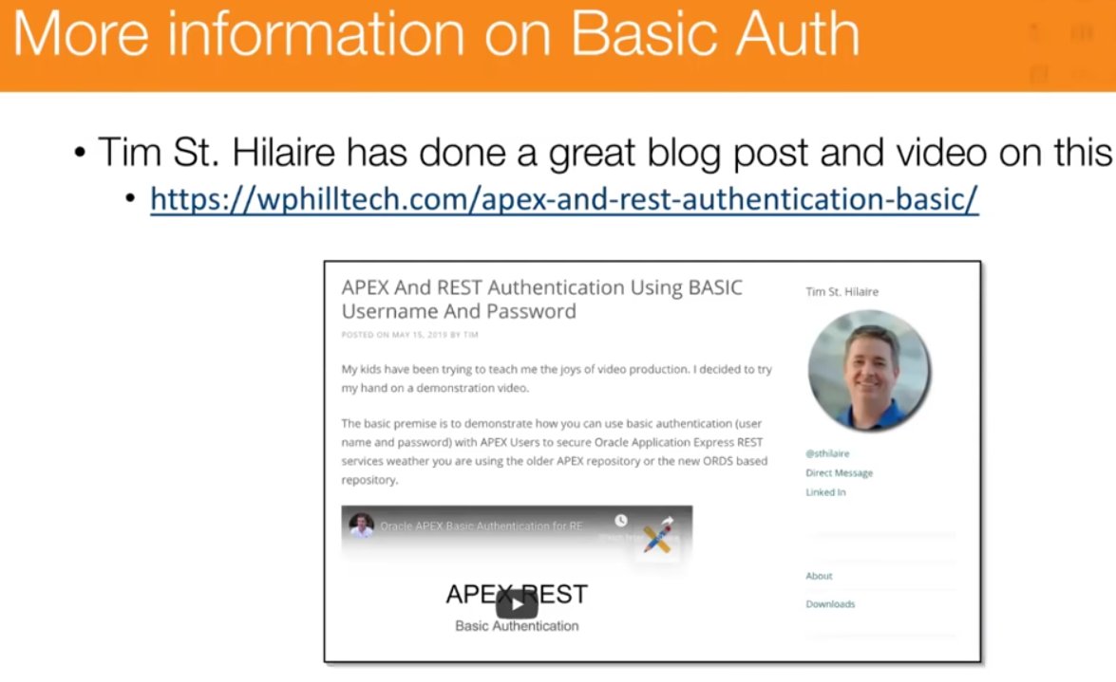

Lets create a new user called milo.

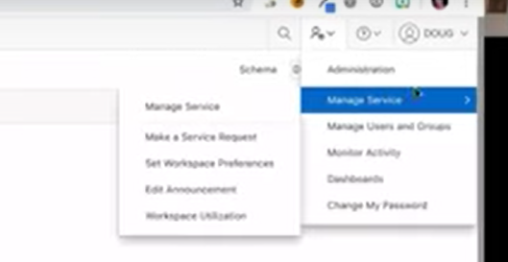

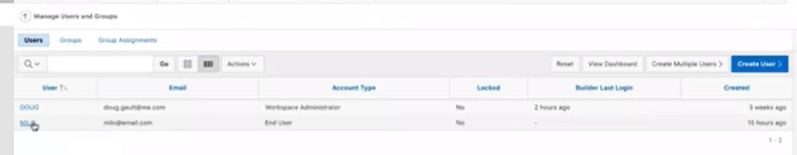

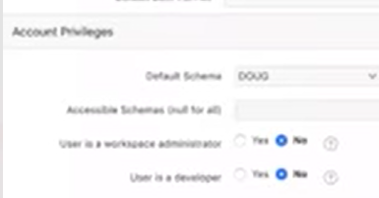 no privs not a developer not a admin.

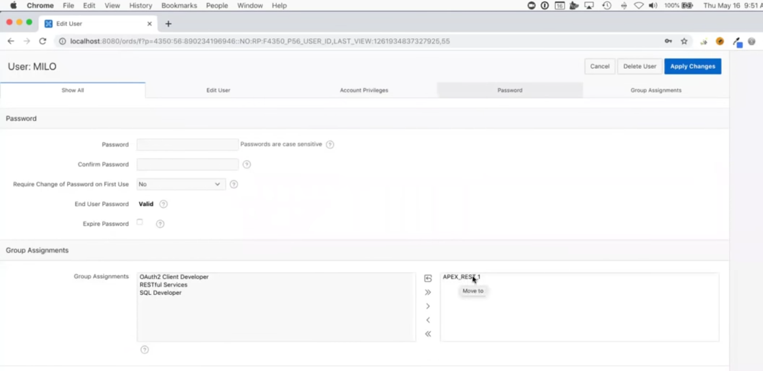

Now lets get to roles and create a role. (new group apex_rest_1) role same name

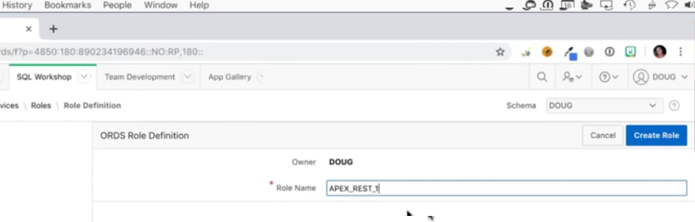

Now lets go create the privilege

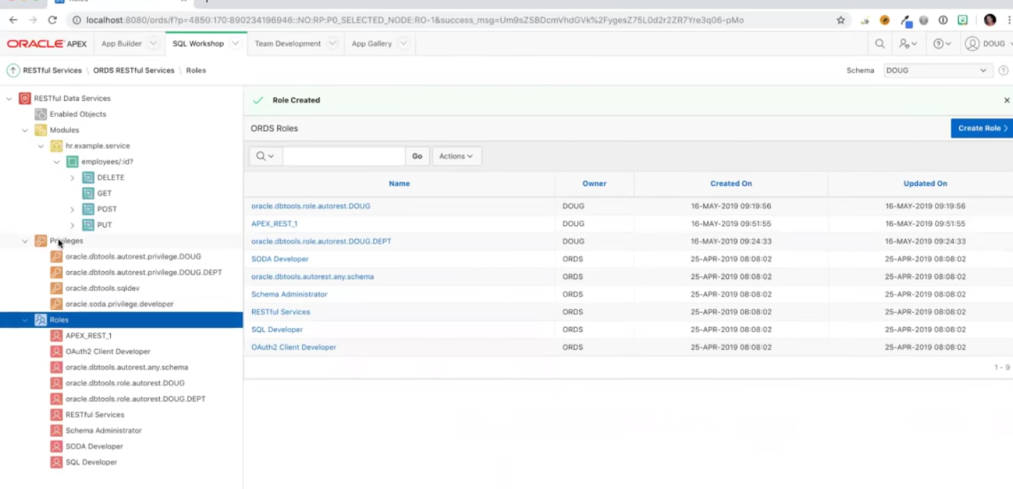

Now let link the module and the privilege together.

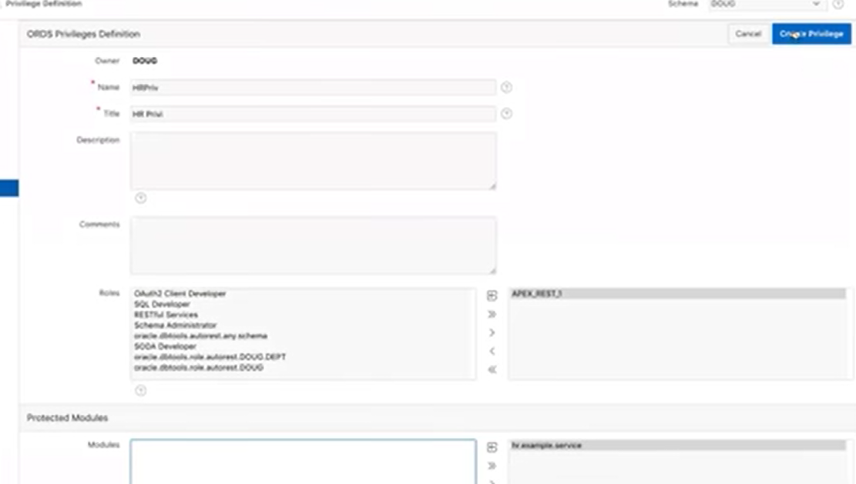

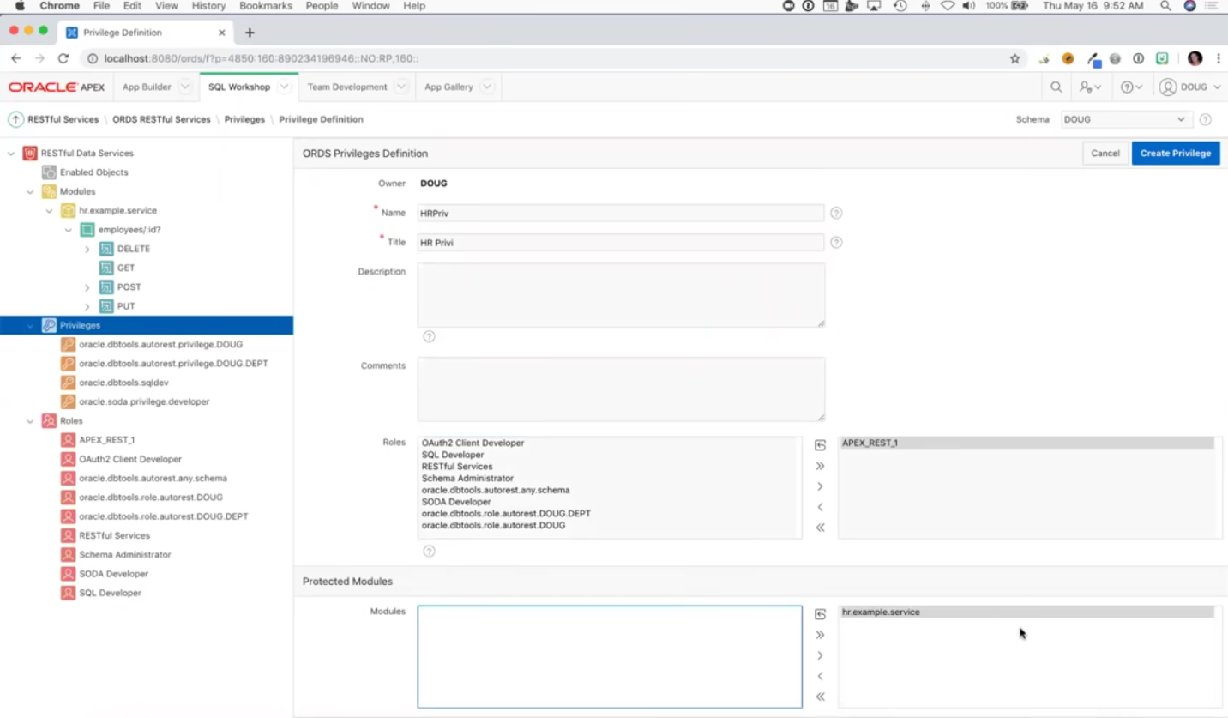

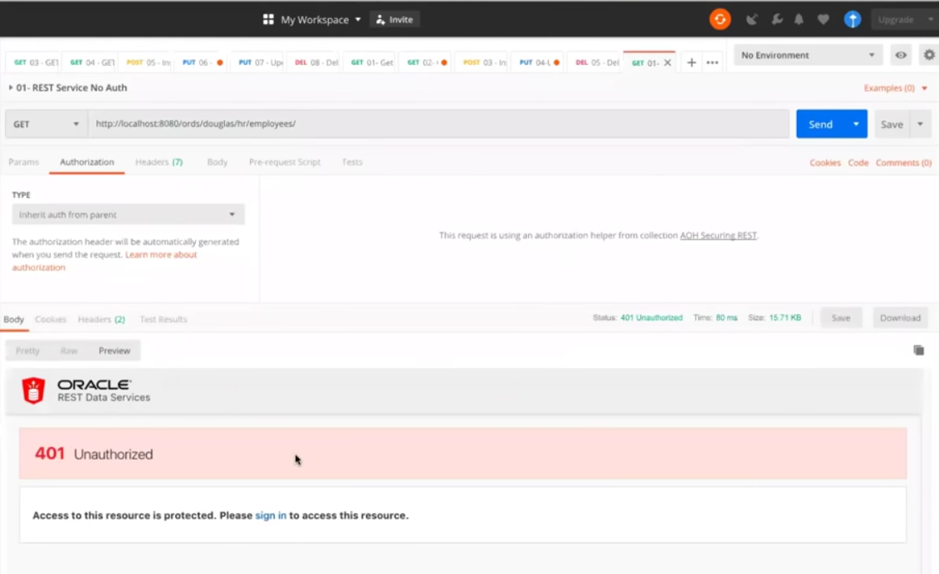

Now if I use milo basic auth

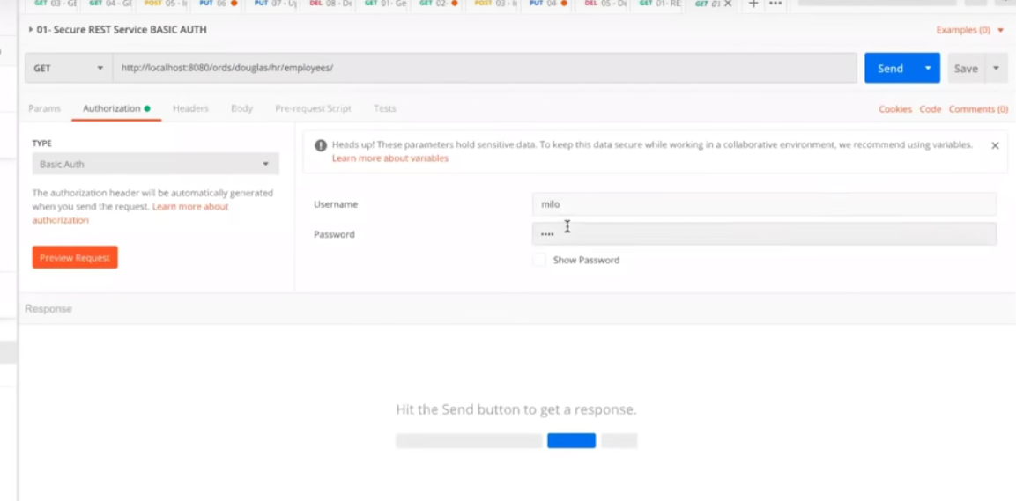

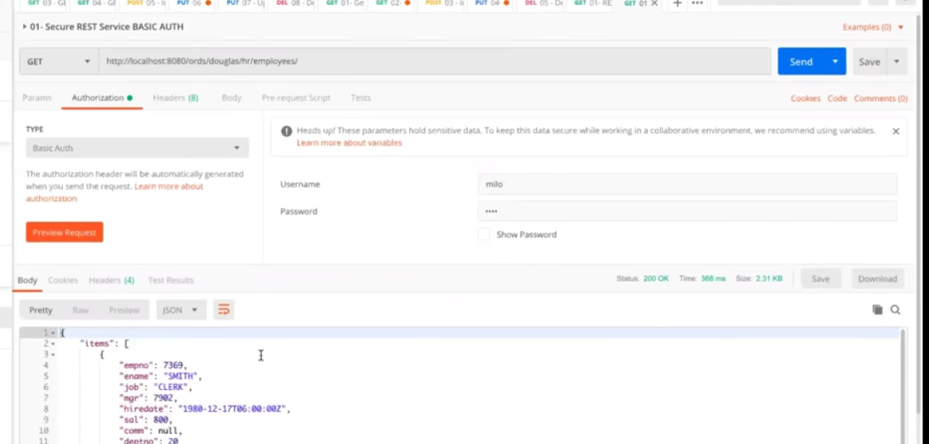

That’s basic auth.

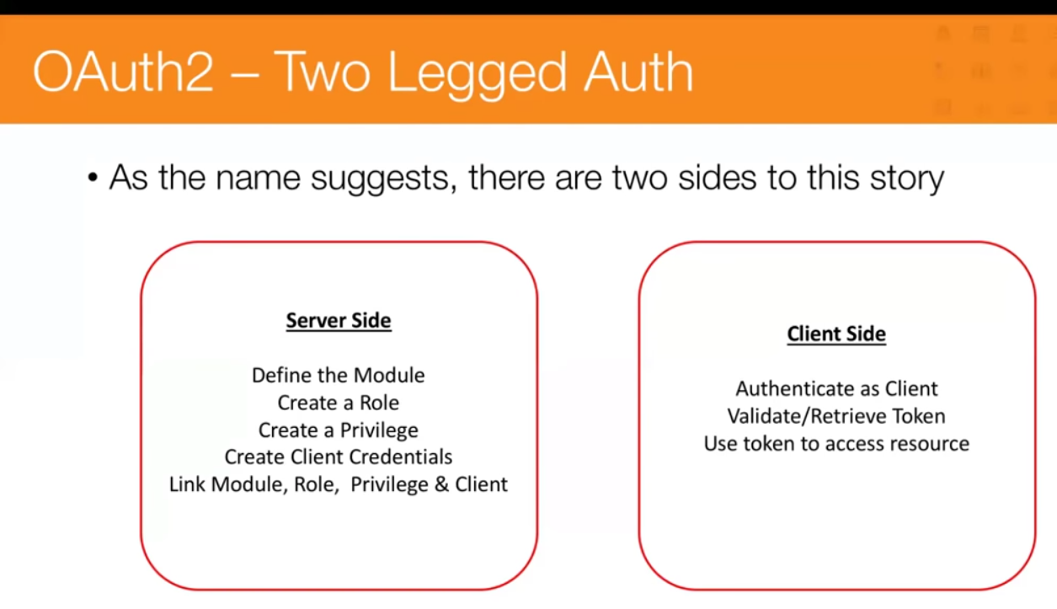

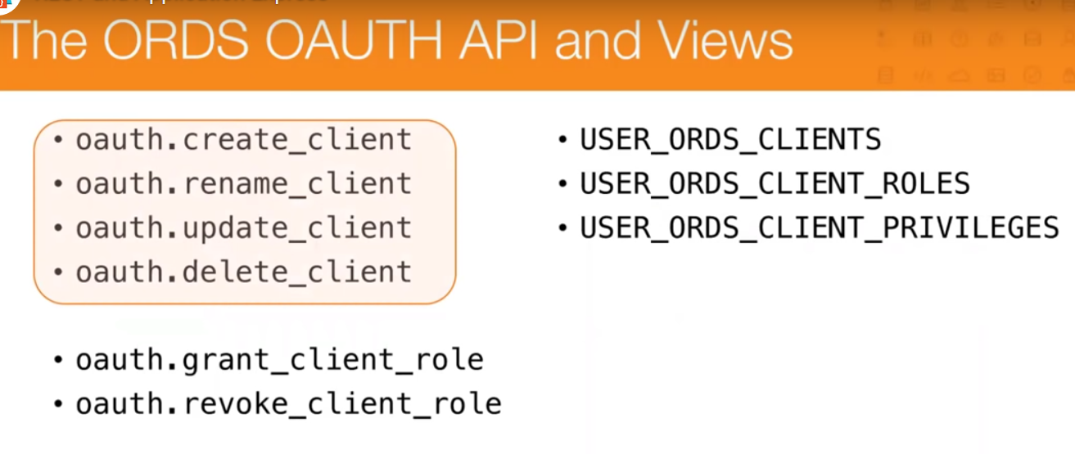

The privilege and the role need to be assigned.

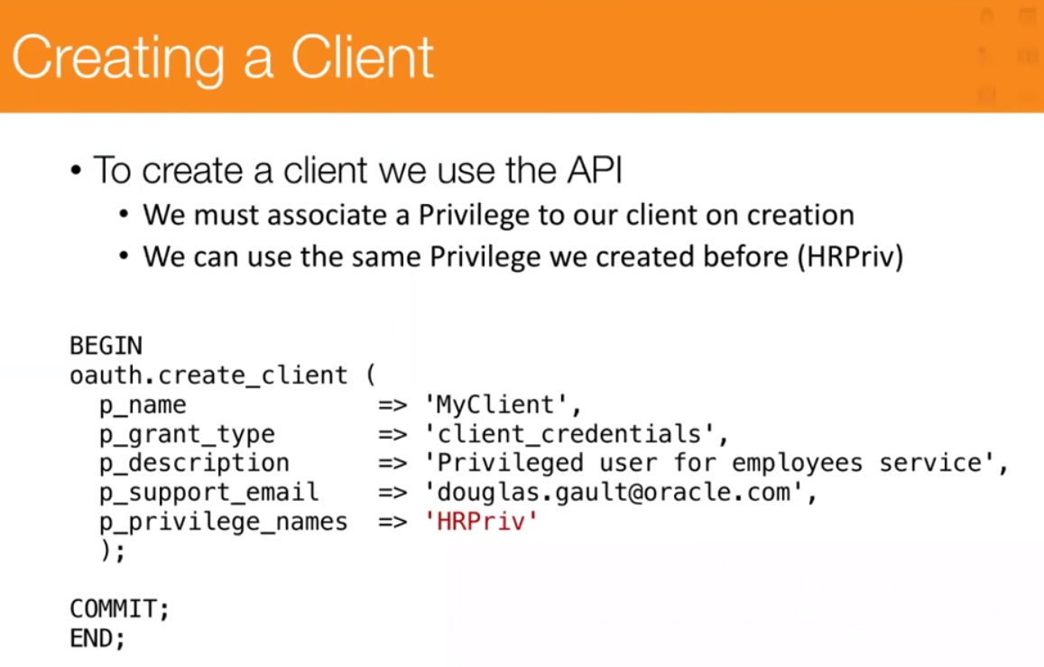

Privilege_name must be created in ords

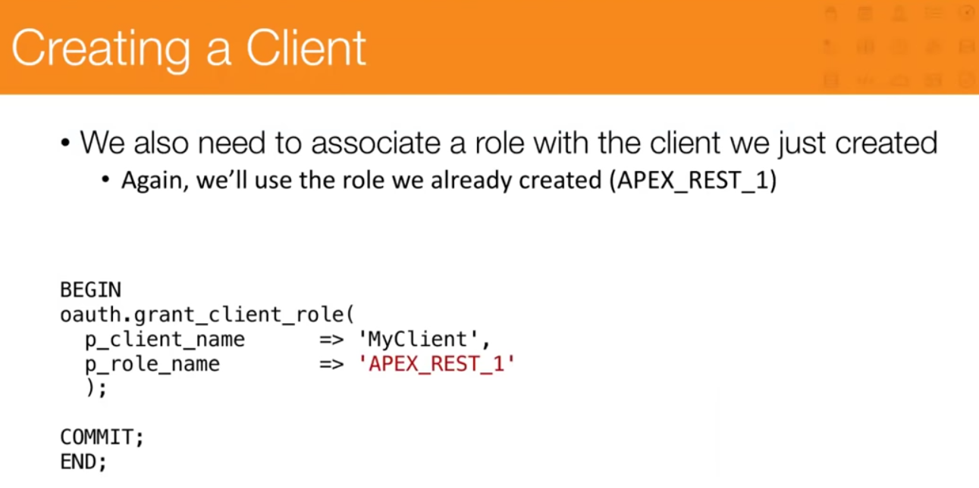

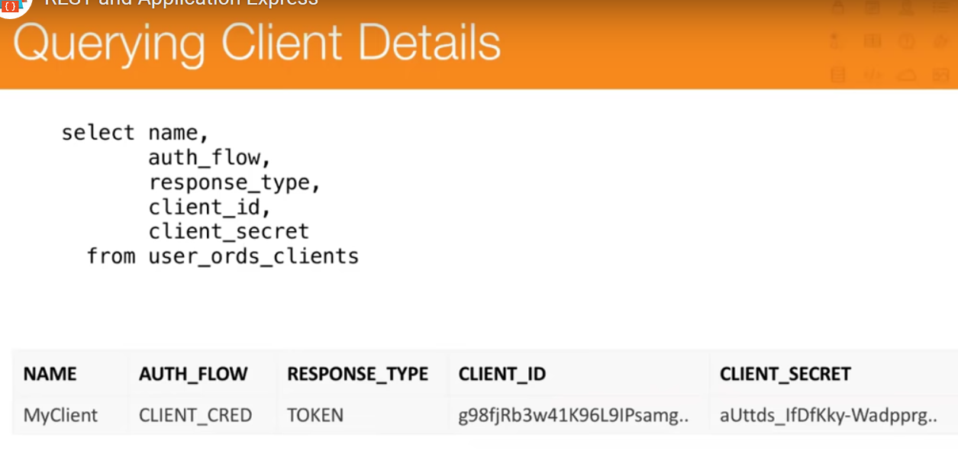

Use it to get a time limited token to get work done.

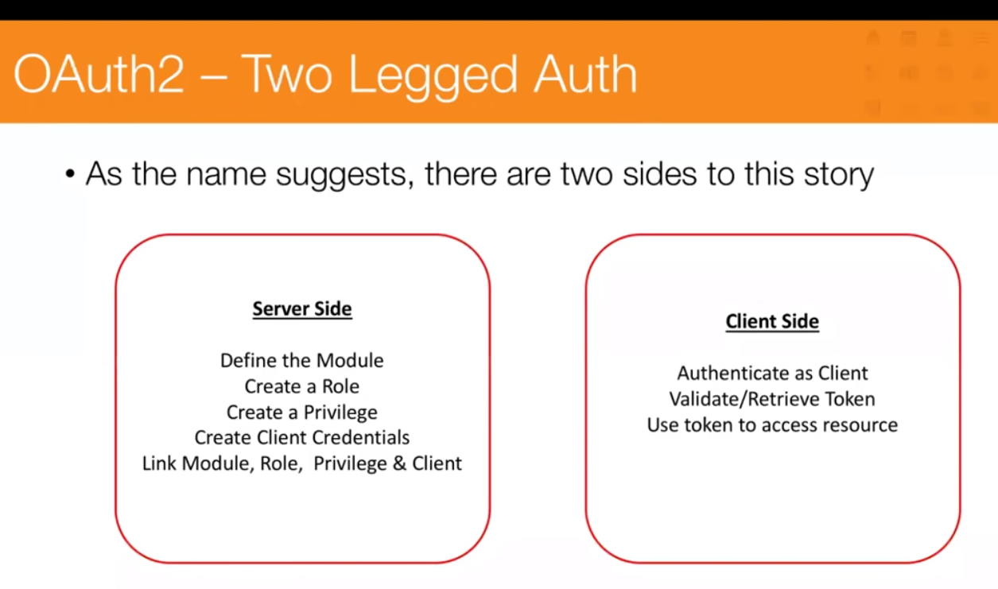

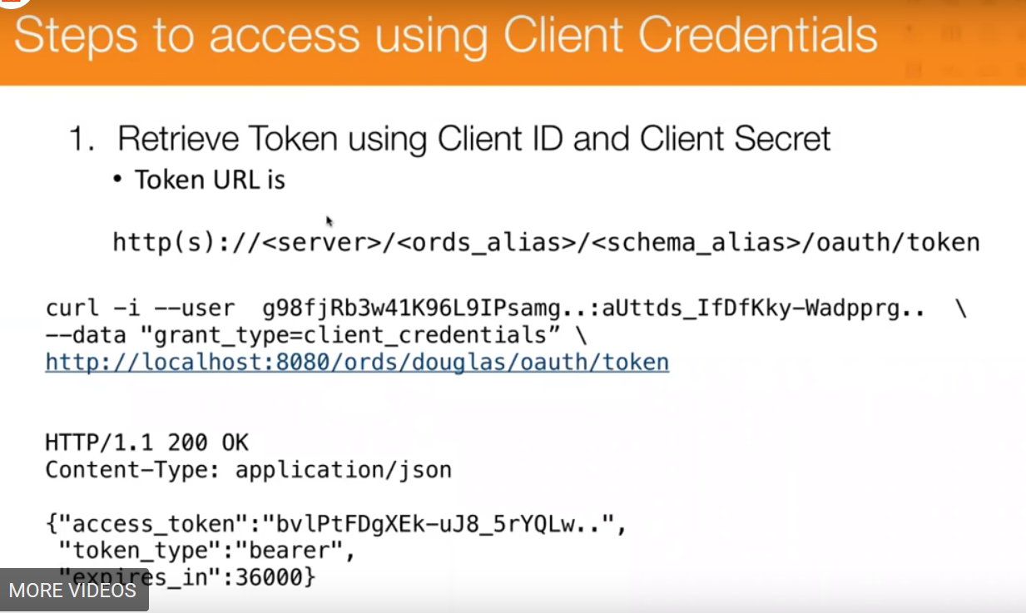

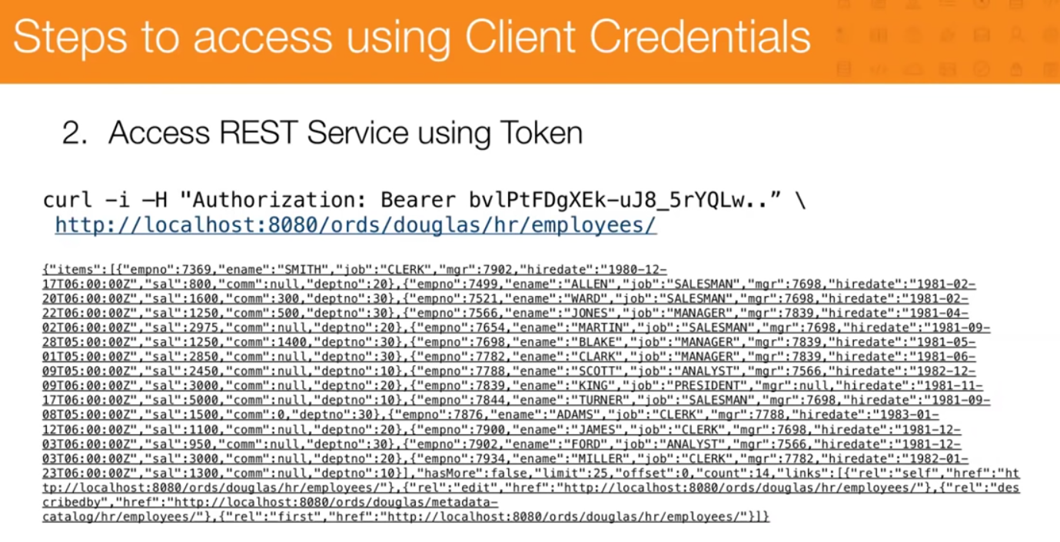

Run the sql below

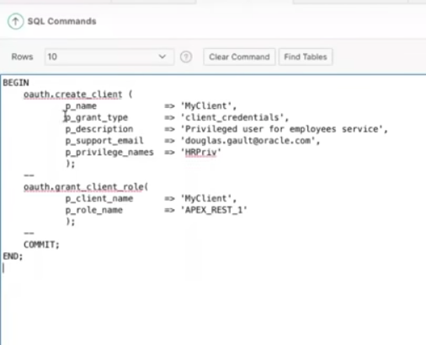

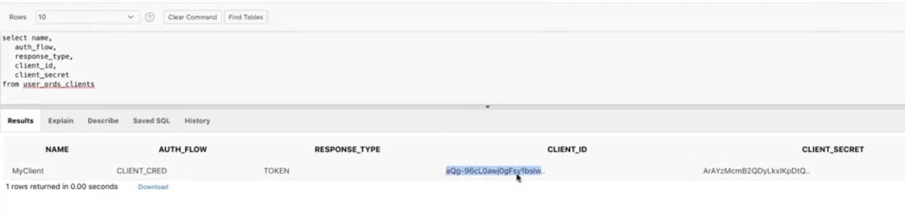

Use them In postman and run the get

Goto auths

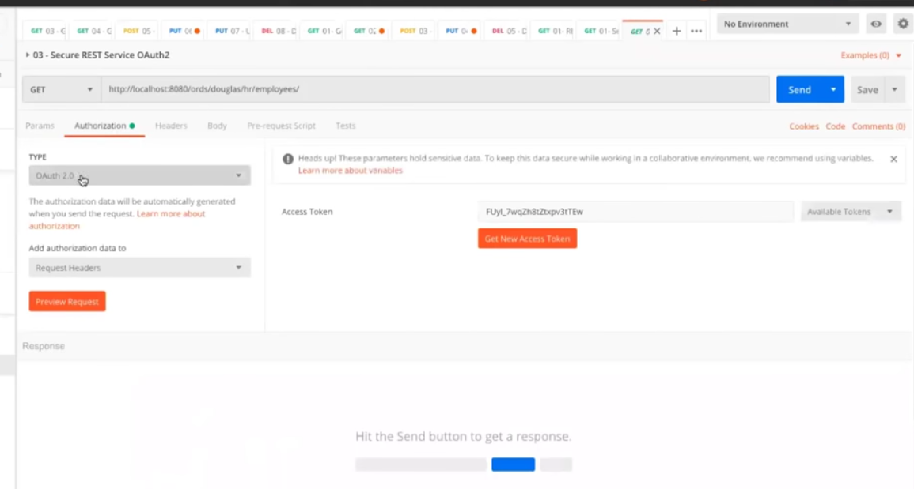

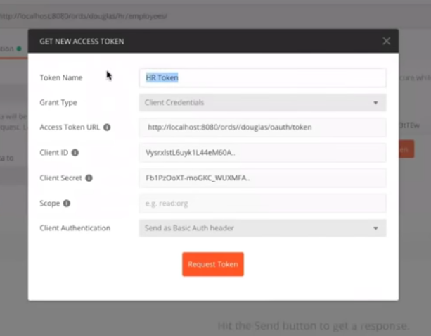

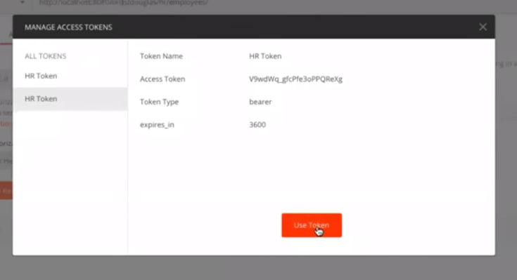

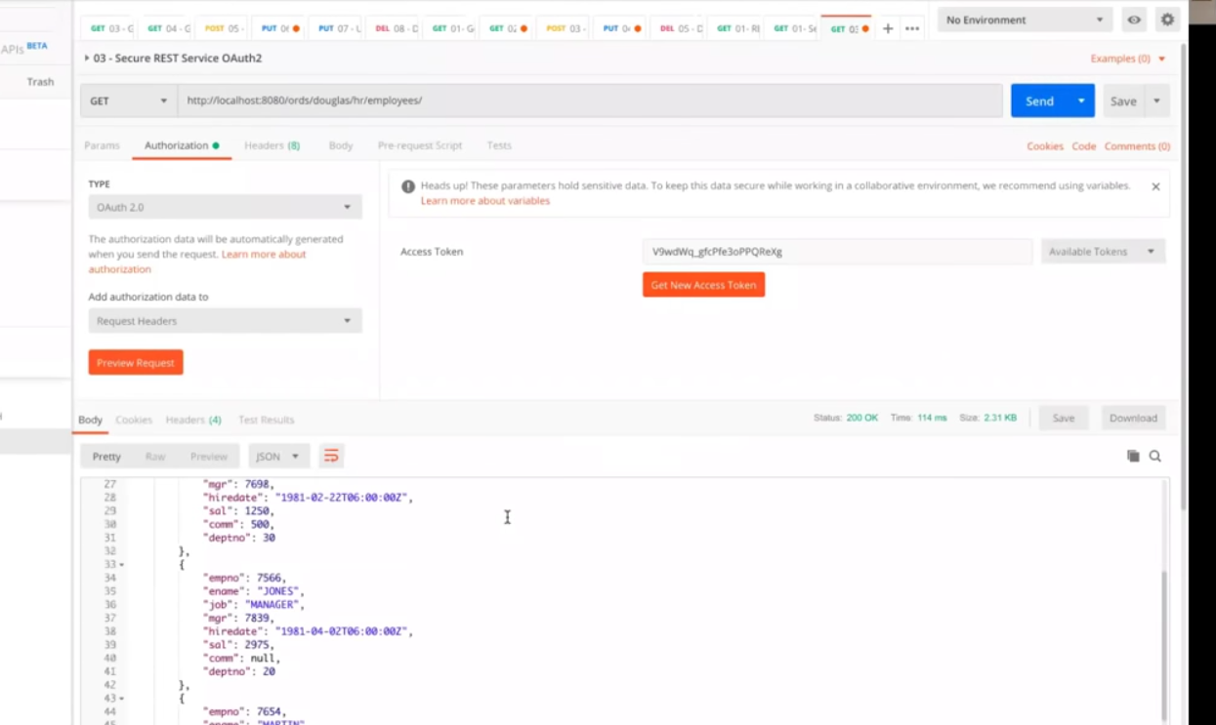

===========consuming web services=====



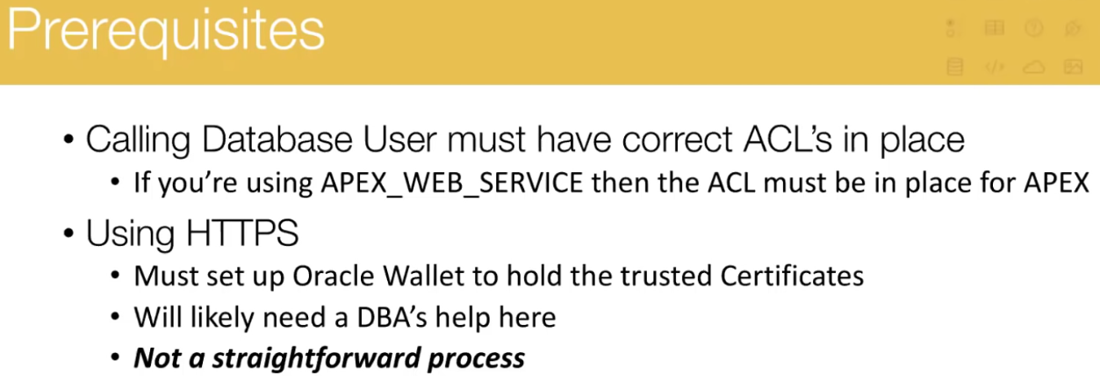

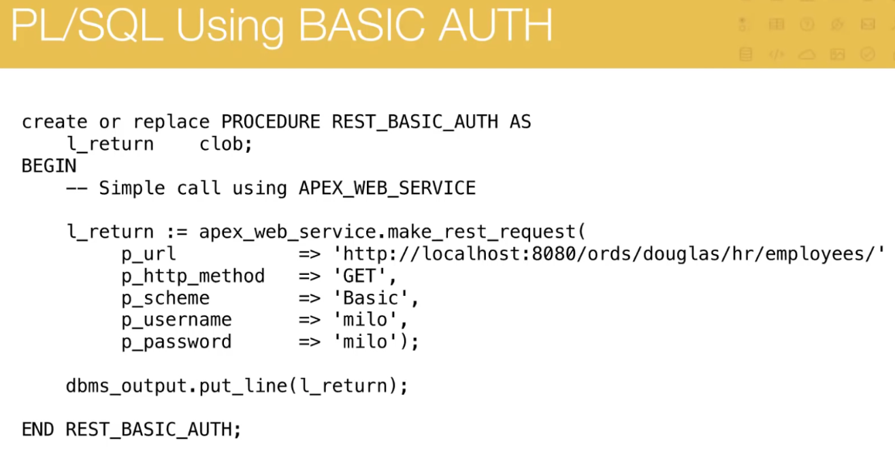

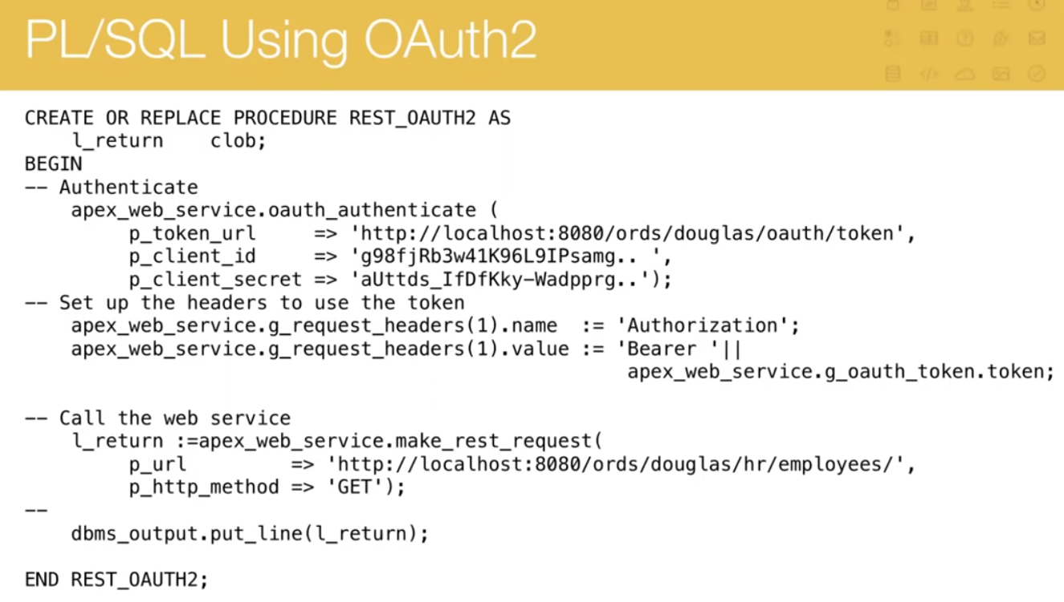

Rest enabled SQL /New section */

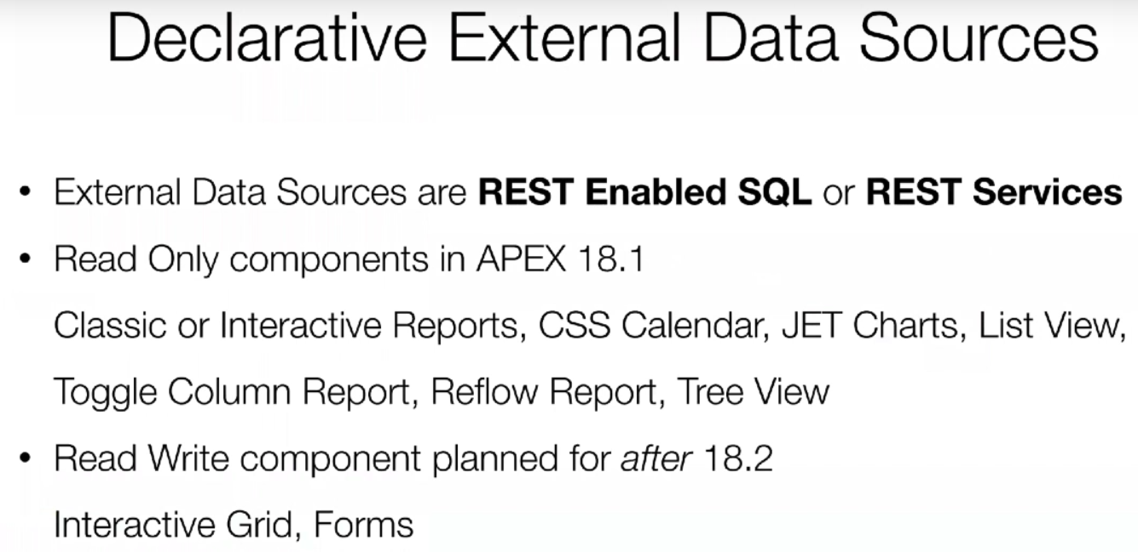

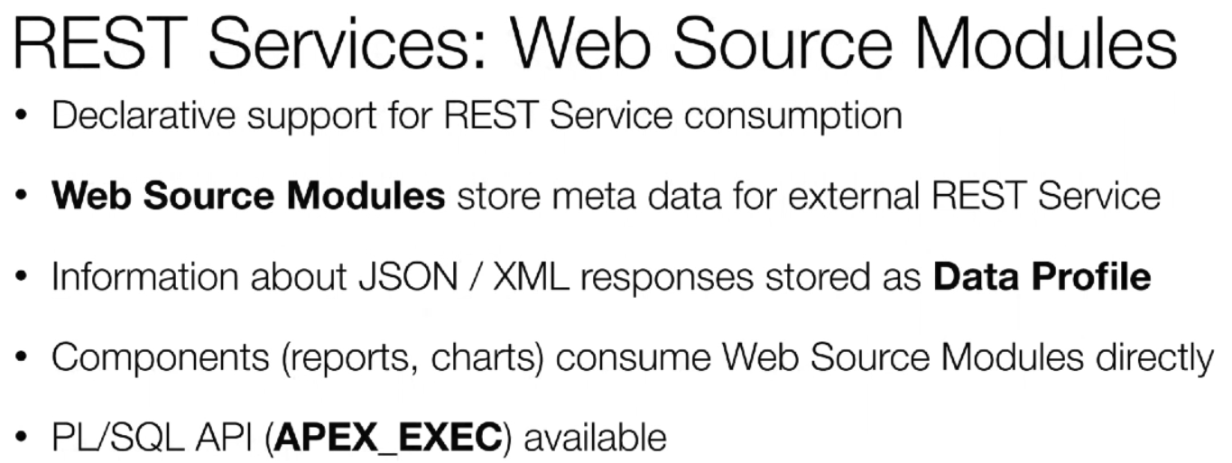

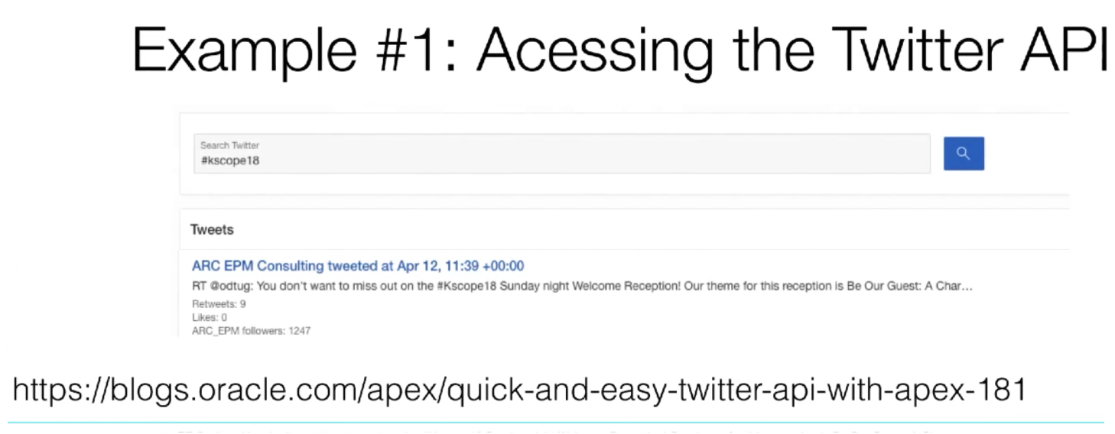

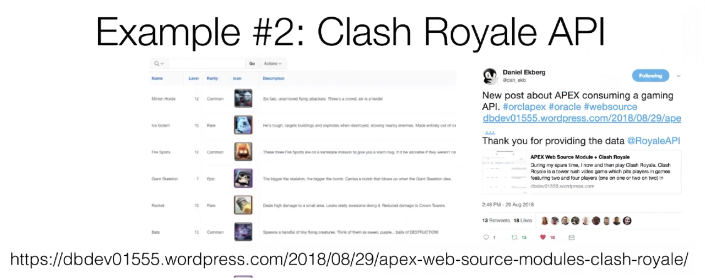

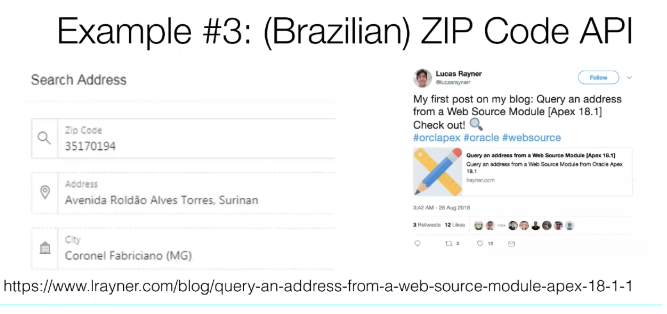

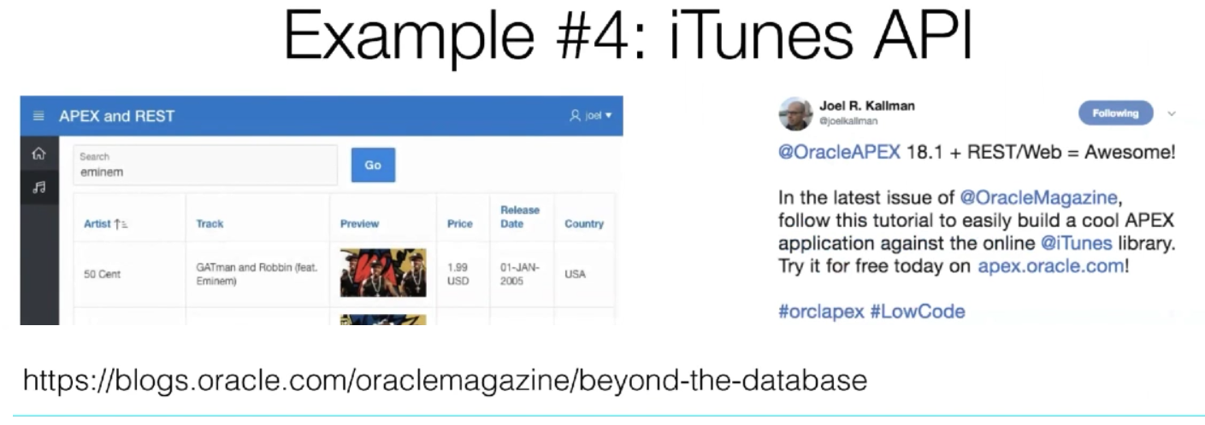

In Shared Components,application properties, if inside the firewall set the proxy server.

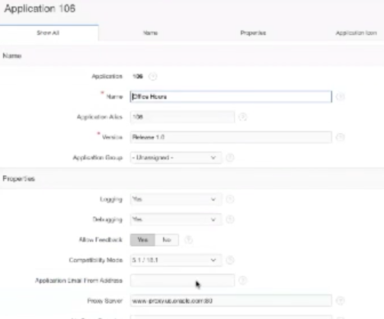

Now goto web source modules in data sources of shared components.

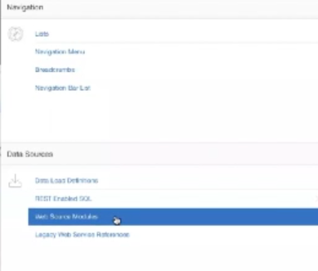 createa web source module from scratch

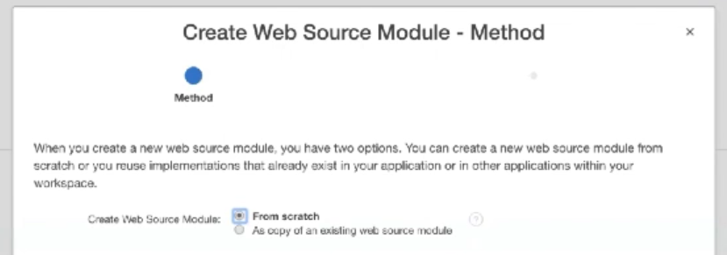

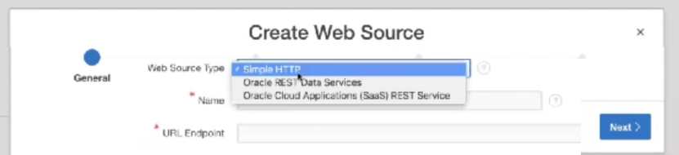

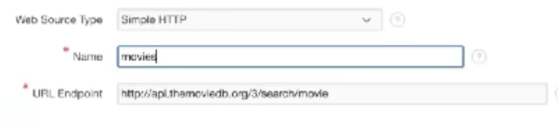

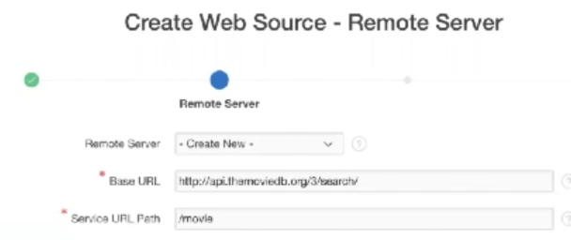

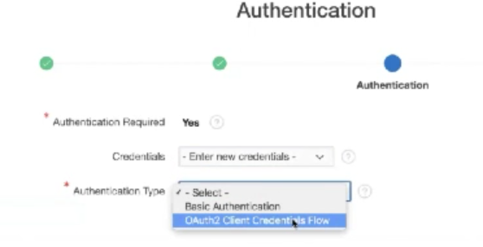

If authentication is via a api key or other than above click on advanced and proceed with filling out individual parameters

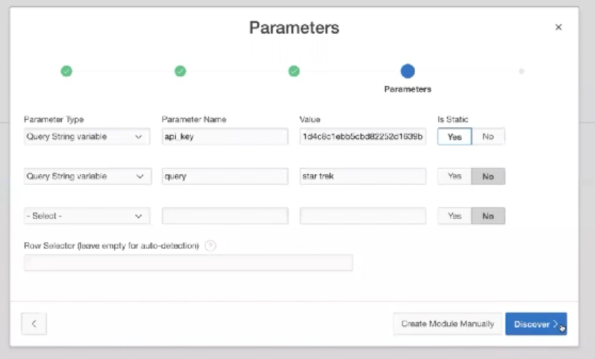

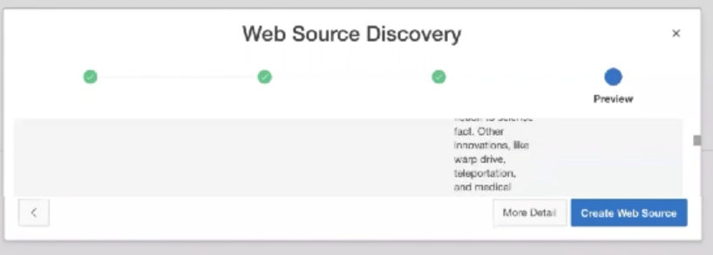

Look at data profile to see that apex turned json to table model of data. Click create web source and now we have meta data for it.

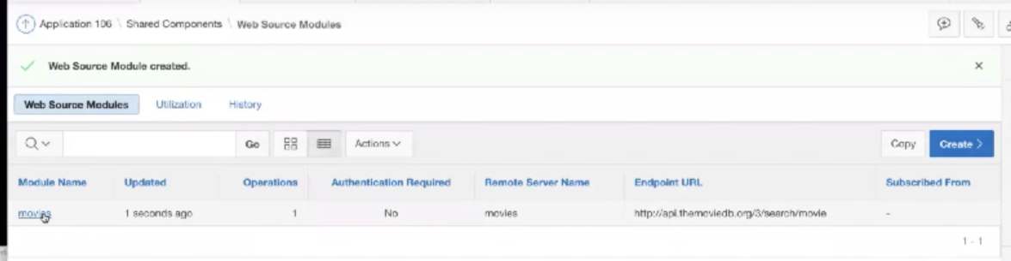

Click on name and see details

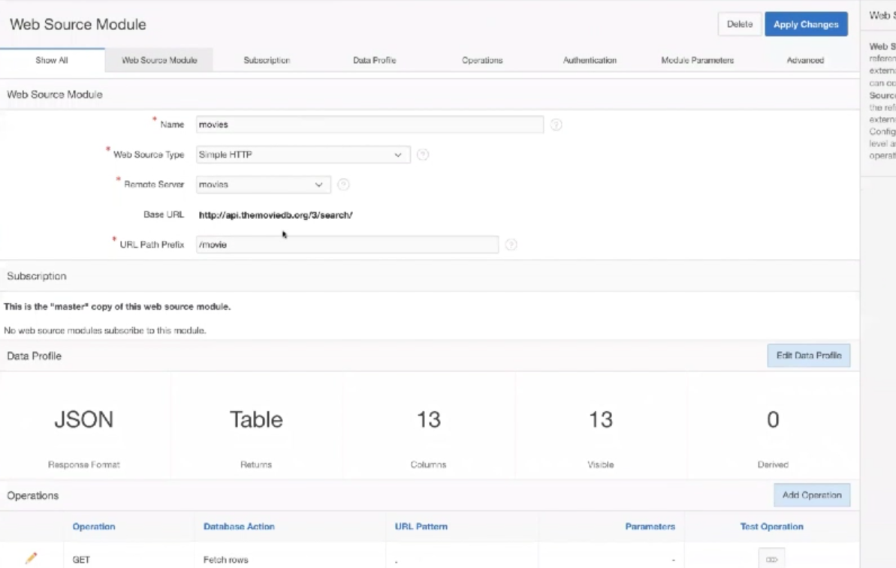

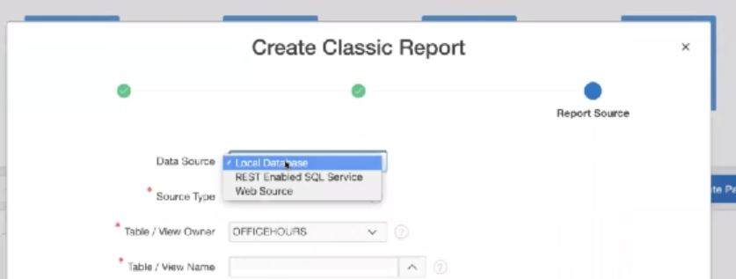

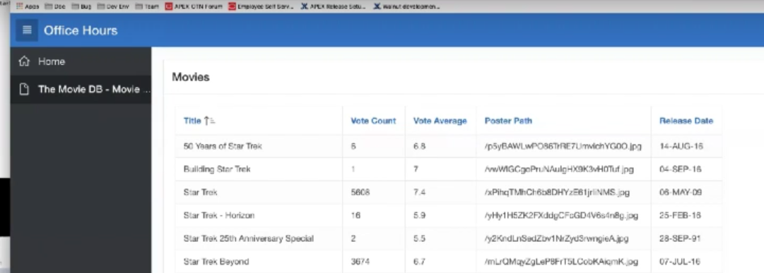

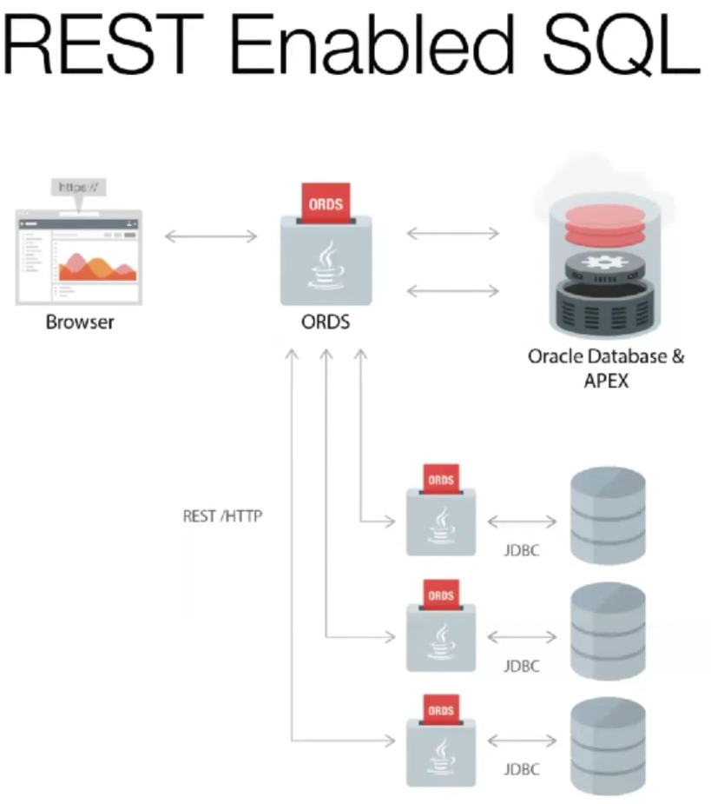

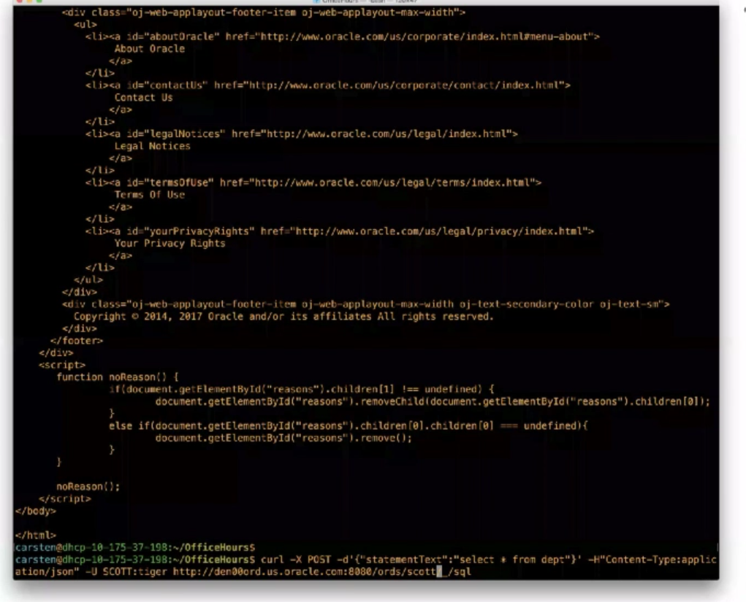

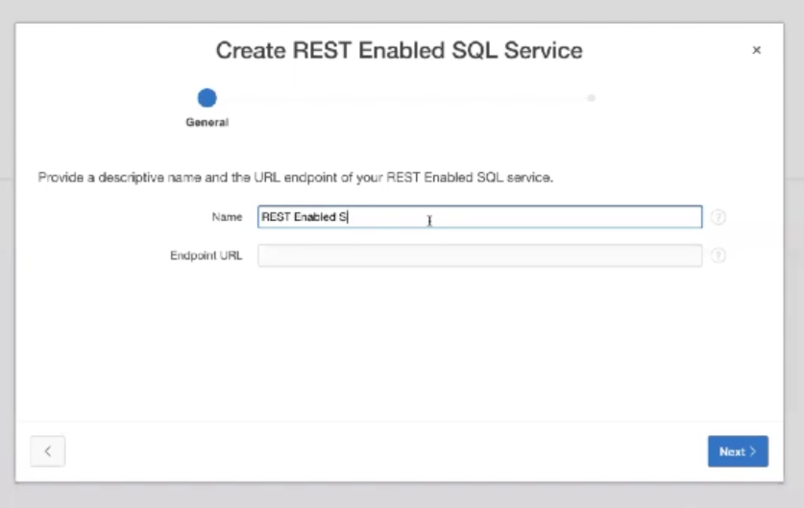

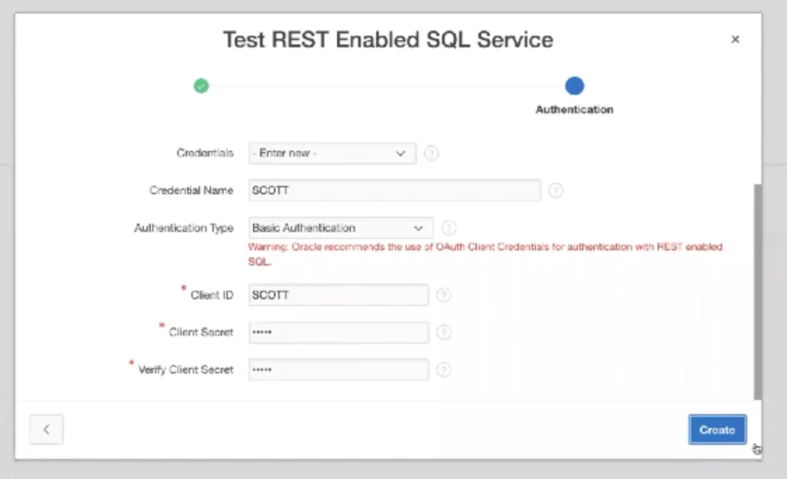

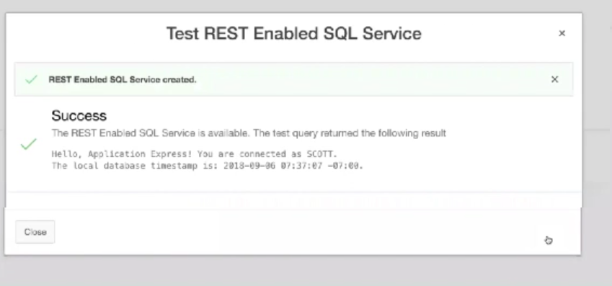

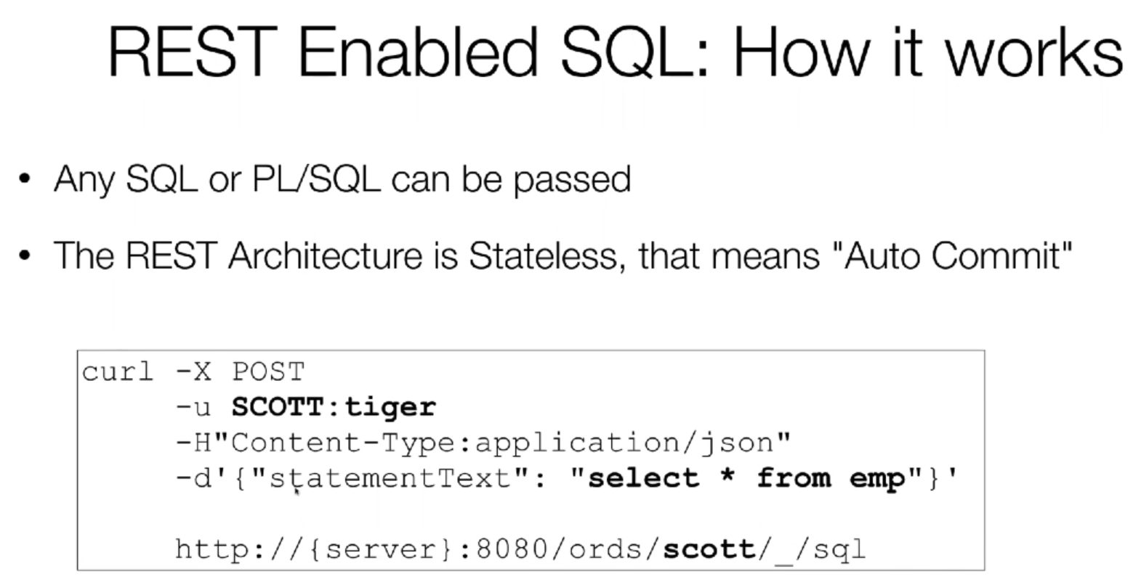

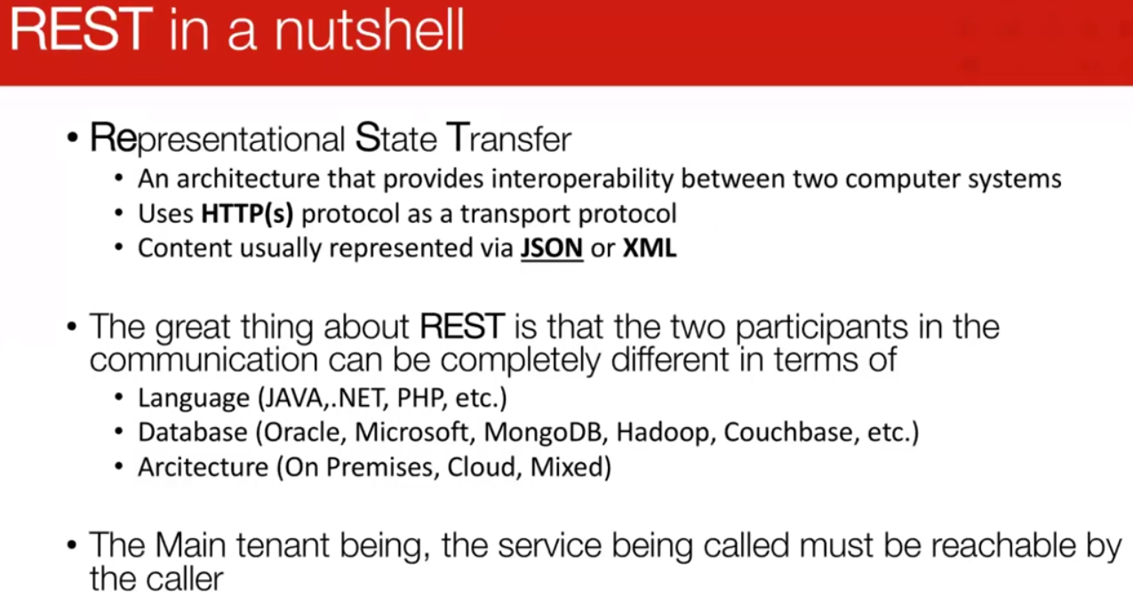

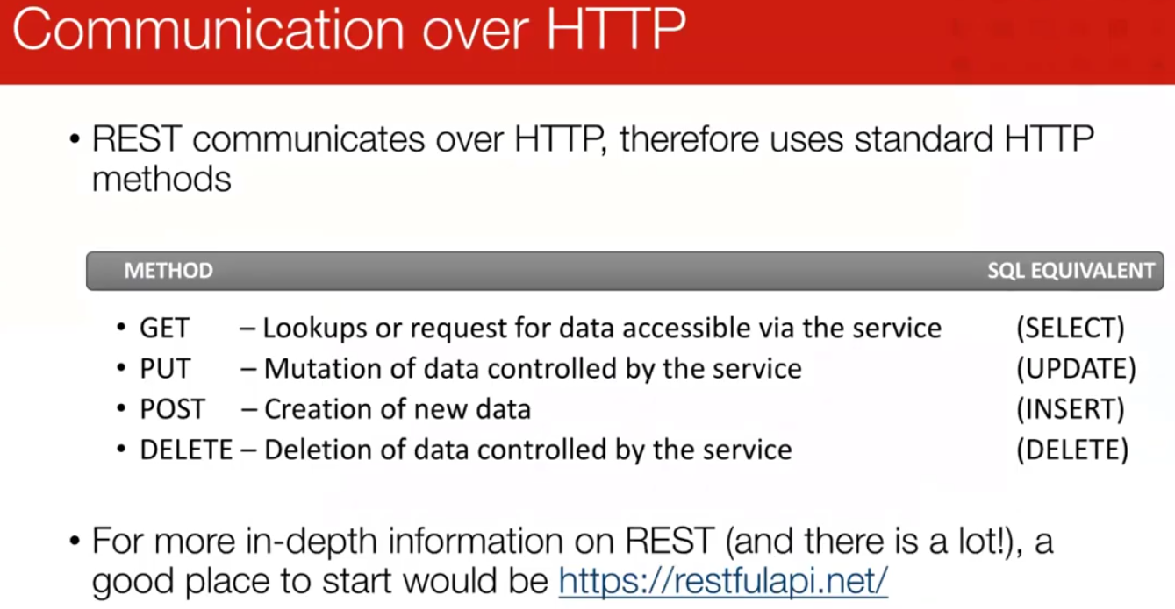

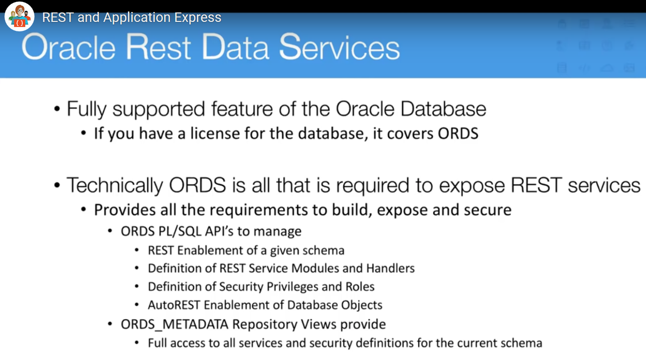

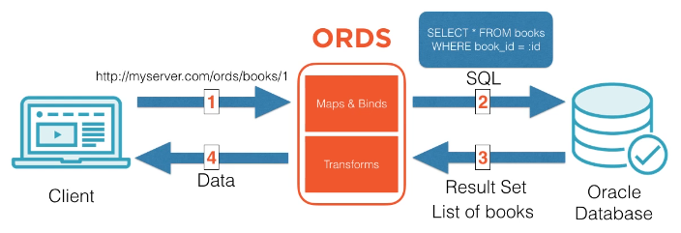

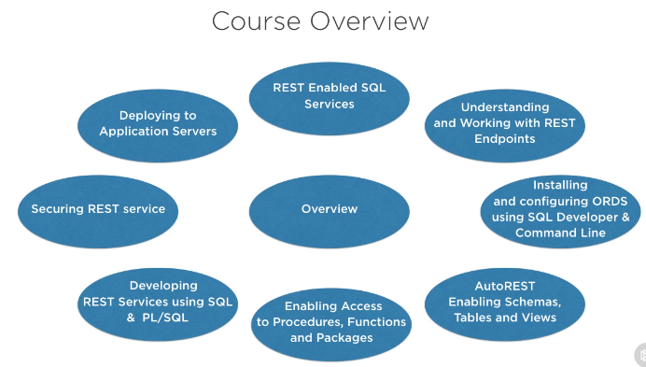

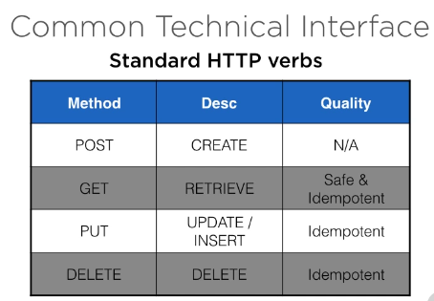

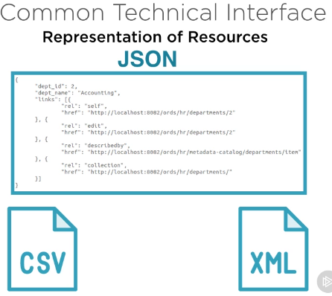

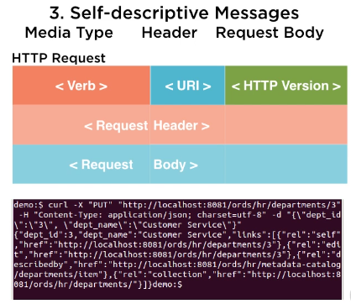

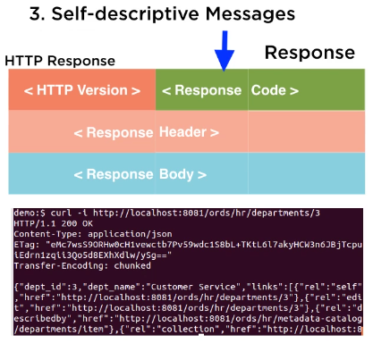status 200 ok (response code)

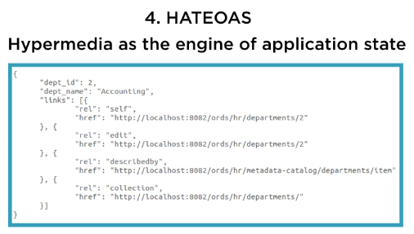

Client can then navigate to other states, discover to other actions.

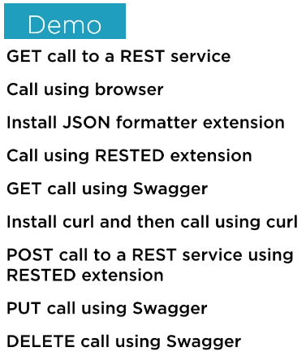

In firefox add extension for json formatter

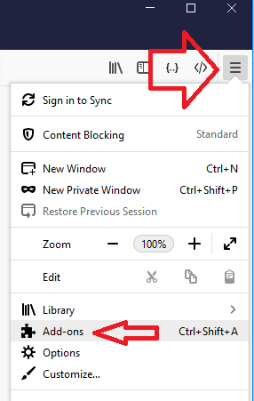

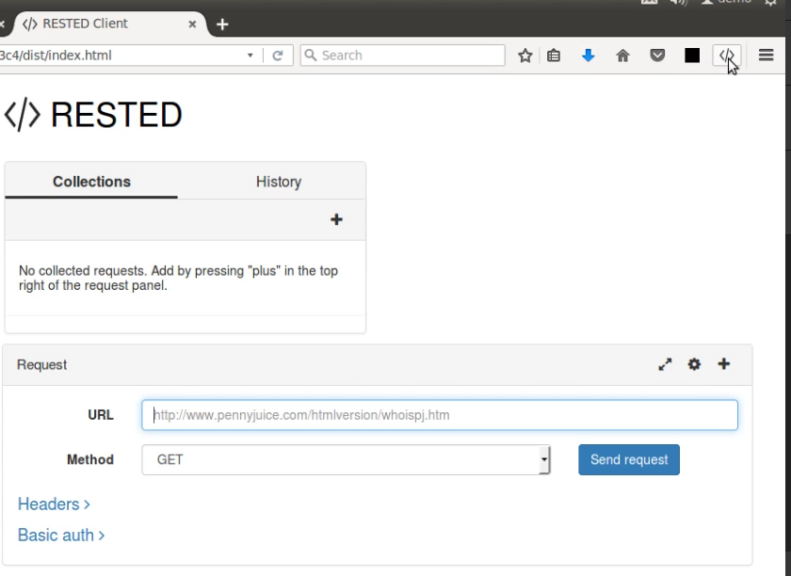

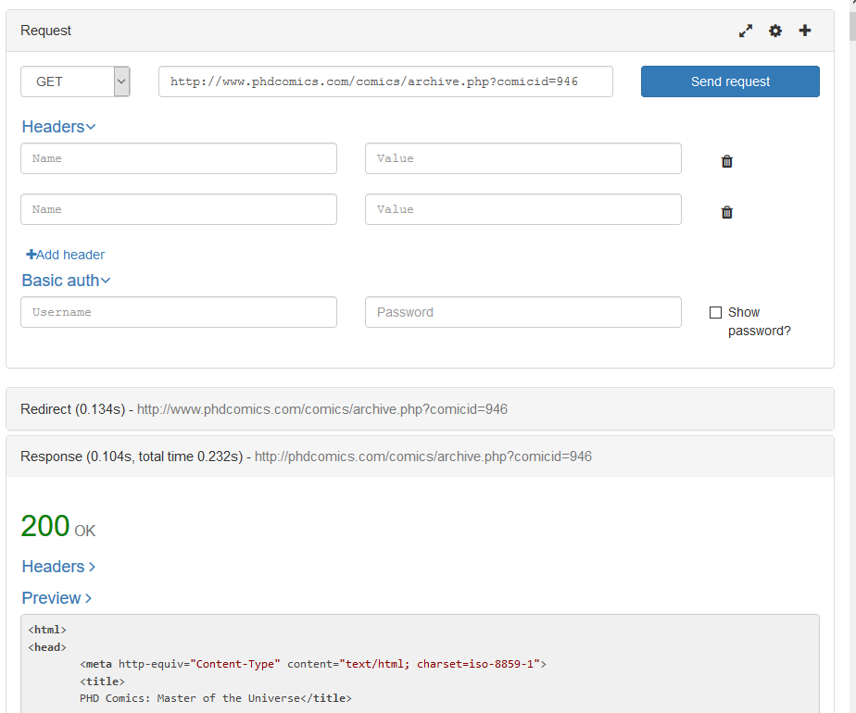

https:/curl

